LESSON DEVELOPMENT FOUR

TWO DIMENSIONAL SHAPES IN OUR ENVIRONMENT

STAGE/TIME | TEACHER’S ACTIVITIES | LEARNER'S ACTIVITIES – MIND/HANDS ON | LEARNING POINTS
Step 1  Introduction – Introductory Activities  (5 minutes) | Asks pupils – what is this?  Guides them to identify the part of object identified – the head, body and tyer.  Asks the pupils to match the part of object identified with a square, rectangle and circle. | 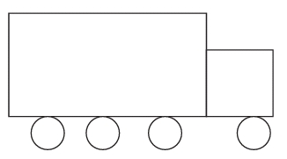  The head –  The body –  The tyers - | Linking the Previous knowledge to the new lesson
Step 2  Development  (5 minutes)  Grouping | 1. Groups the learners into four groups – A, B, C, and D.  2. Guide the learners to choose a leader and secretary for your group.  3. Gives each group learning materials – chart showing different two dimensional shapes | 1. Belong to a group.  2. Choose their leader and secretary.  3. Received learning materials for their group. | Learner’s group, leader and secretary confirmed.
Step 3  Development – Groups Activities  (5 minutes) | Asks pupils to match the three dimensional shapes with two dimensional shapes. | 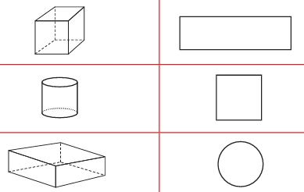 | Two dimensional in our environment
Step 5  Development – Groups Activities  (5 minutes) | Guides pupils to group the following objects into objects at home or in the school. | 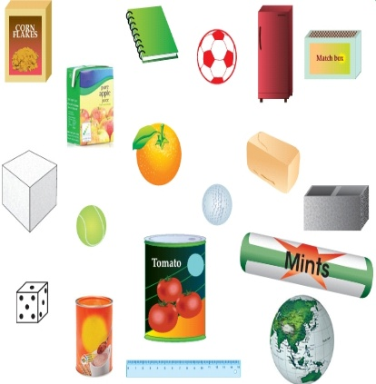 | Grouping - Objects at home or in the school.
Step 4  Development – Groups Activities and Presentation  ( 15 minutes) | Guides the pupils to identify square, rectangle and circle in the following three dimensional shapes. |  | Two dimensional in our environment
Step 5  Development  (5 minutes) | To conclude the lesson, the teacher revises the entire lesson and ask the key questions. | The learners listen, ask and answer questions. | Lesson Evaluation and Conclusion

Reference book – New Method Mathematics Book 1 2 3

Instructional Materials

