LESSON DEVELOPMENT TWO

IDENTIFYING AND NAMING TWO - DIMENSIONAL SHAPES
(SQUARE, RECTANGLE AND CIRCLE)

STAGE/TIME | TEACHER’S ACTIVITIES | LEARNER'S ACTIVITIES – MIND/HANDS ON | LEARNING POINTS
Step 1  Introduction – Introductory Activities  (5 minutes) | Guides the pupils to sort the shapes according to how they look alike. | 3 shapes look like this shape –  7 shapes look like this shape –  5 shapes look like this shape – | Linking the Previous knowledge to the new lesson
Step 2  Development  (5 minutes)  Grouping | 1. Groups the learners into four groups – A, B, C, and D.  2. Guide the learners to choose a leader and secretary for your group.  3. Gives each group learning materials – dice, match box and peak milk tin. Cut the shape of square, rectangle and circle. | 1. Belong to a group.  2. Choose their leader and secretary.  3. Received learning materials for their group. | Learner’s group, leader and secretary confirmed.
Step 3  Development – Groups Activities  (5 minutes) | Asks pupils –  1. Trace out the face of a ludo dice.  2. Do the same for all the faces  3. Collect the shapes that look like the faces from the shape box.  Tells them – The faces you have traced are called squares. |  | Identifying and naming square
Step 4  Development – Groups Activities  (5 minutes) | Asks pupils –  1. Trace out the face of a match box.  2. Do the same for all the faces.  3. Collect the shapes that look like the faces from the shape box.  Tells them – The faces you have traced are called rectangle. |  | Identifying and naming rectangle
Step 5  Development – Groups Activities  (5 minutes) | Asks pupils –  1. Trace out the face of a peak milk tin.  2. Do the same for all the faces.  3. Collect the shapes that look like the faces from the shape box.  Tells them – The faces you have traced are called circle. |  | Identifying and naming circle
Step 6  Development – Groups Activities and Presentation  (5 minutes) | Asks pupils – Name each shape. | 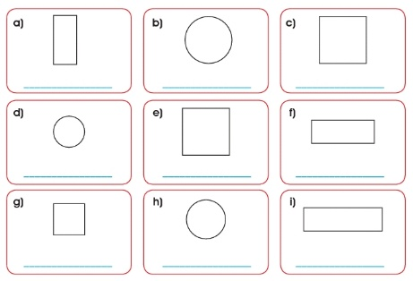 | Naming square, rectangle and circle
Step 7  Development  (5 minutes) | To conclude the lesson, the teacher revises the entire lesson and ask the key questions.  SUMMARY AND KEY QUESTIONS  Write the name of each traced shape in your notebook. | The learners listen, ask and answer questions.  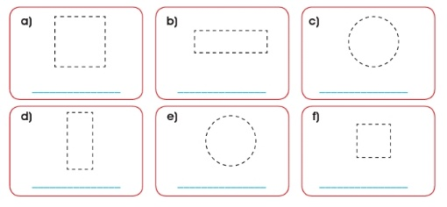 | Lesson Evaluation and Conclusion

Reference book – New Method Mathematics Book 1 2 3
Instructional Materials

