LESSON DEVELOPMENT ONE

MEANING OF ENERGY

STAGE/TIME | TEACHER’S ACTIVITIES | LEARNER'S ACTIVITIES – MIND/HANDS ON | LEARNING POINTS
Step 1  Introduction – Introductory Activities  (5 minutes) | Asks pupils to rub their palm very quickly along the table (or another surface). What happens?  Explain to pupils that the palm  has movement energy. It is changing to heat and sound energy.  Tells them that they will be learning about the different forms of energy in today’s lesson | Palms get hot and there may be a sound.  Listen to teacher’s explanation. | Linking the Previous knowledge to the new lesson
Step 2  Development  (5 minutes)  Grouping | 1. Groups the learners into four groups – A, B, C, and D.  2. Guide the learners to choose a leader and secretary for your group.  3. Gives each group learning materials – Cardboard papers, markers, the relevant pictures/chart. Real objects: A transistor radio, a torch light with batteries. | 1. Belong to a group.  2. Choose their leader and secretary.  3. Received learning materials for their group. | Learner’s group, leader and secretary confirmed.
Step 3  Development  (5 minutes) | Lists these types of energy on the board. Light, Sound, Movement, Stored, Electrical, Heat.  Asks pupils to say what they understand by energy.  Asks them to stand up and show how a person with a lot of energy acts.  Asks them to sit down and show how a person with little energy acts. | Take down different types of energy.  Energy is the ability to do work.  They act very strong.  They act very weak. | Form of energy
Step 4  Development – Groups Activities  (10 minutes) | GUIDED INSTRUCTIONS  Asks the groups to put on the torchlight with batteries inside it and shine the light on the wall.  Asks them what type of energy this. Open the torch and take out the battery.  Show that the torch does not work now. What type of energy comes from the battery?  Take the radio and put it on. (Make sure that the volume is loud enough).  Asks them what type of energy it gives out and what type it needs to work.  Copy and complete the table and fill in the first two rows.  Asks each group to display the chart on the board.  Asks each each to choose three pictures from the chart and discuss what type of energy goes in and what comes out. | Light energy  Electricity  It gives sound energy and needs electricity to work.  A = Type of energy in.  B = Type of energy out.  Objects A B  Torch Electricity Light  Radio Electricity Sound  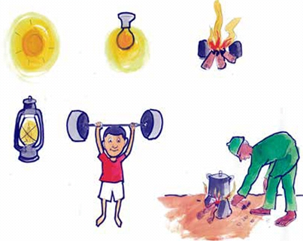  Objects A B | Groups work
Step 5  Development  (15 minutes) | Asks each group to present their results/solutions so that you can compare responses with those in other groups. | Presentation - Call on any member of at least two pairs in each to make presentation to the class. | Group Presentation
Step 6  Conclusion  (5 minutes) | To conclude the lesson, the teacher revises the entire lesson and ask the key questions. | The learners listen, ask and answer questions. | Lesson Evaluation and Conclusion

Reference book – Primary 5 Basic Science & Technology

