LESSON DEVELOPMENT ONE

PICTOGRAM

STAGE/TIME | TEACHER’S ACTIVITIES | LEARNER'S ACTIVITIES – MIND/HANDS ON | LEARNING POINTS
Step 1  Introduction – Introductory Activities  (5 minutes) | Guides the pupils to identify the following animals on chart. | 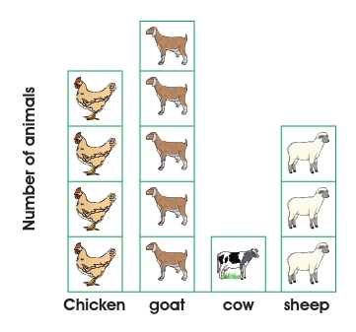 | Linking the Previous knowledge to the new lesson
Step 2  Development  (5 minutes)  Grouping | 1. Groups the learners into four groups – A, B, C, and D.  2. Guide the learners to choose a leader and secretary for your group.  3. Gives each group learning materials – chart showing different animals. | 1. Belong to a group.  2. Choose their leader and secretary.  3. Received learning materials for their group. | Learner’s group, leader and secretary confirmed.
Step 3  Development – Groups Activities  (10 minutes) | The pictures in the graph show the number of livestock and chicken in Michael’s farm.  Guides the pupils to copy and complete the following. Michael has:  1. Chicken  2. Goats  3. Cows  4. Sheep | 1. 4 Chickens  2. 5 Goats  3. 1 Cow  4. 3 Sheep | Interpreting Pictogram
Step 4  Development - Groups Activities  (10 minutes) | 5. The sheep is more than the goats.  6. The cow is more than the sheep  7. The ____________ is the most bred of Michael’s animal.  8. The total number of animals in Michael’s farm is . | 5. No  6. No  7. Goats  8. 13 | Groups work – Interpreting Pictogram
Step 5  Development – Groups Presentation  (10 minutes) | Asks each group to present their results/solutions so that you can compare responses with those in other groups. | Presentation - Call on any member of at least two pairs in each to make presentation to the class. | Group Presentation
Step 6  Conclusion  (5 minutes) | To conclude the lesson, the teacher revises the entire lesson and ask the key questions. | The learners listen, ask and answer questions. | Lesson Evaluation and Conclusion

Reference book – New Method Mathematics

