LESSON DEVELOPMENT TWO

PICTOGRAM

STAGE/TIME | TEACHER’S ACTIVITIES | LEARNER'S ACTIVITIES – MIND/HANDS ON | LEARNING POINTS
Step 1  Introduction – Introductory Activities  (5 minutes) | Guides the pupils to identify the following animals on chart. | 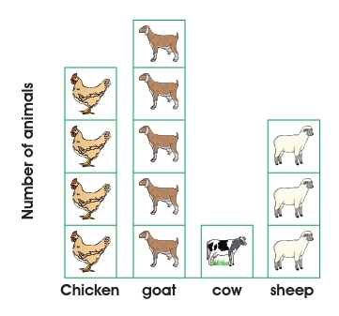 | Linking the Previous knowledge to the new lesson
Step 2  Development  (5 minutes)  Grouping | 1. Groups the learners into four groups – A, B, C, and D.  2. Guide the learners to choose a leader and secretary for your group.  3. Gives each group learning materials – chart showing different animals. | 1. Belong to a group.  2. Choose their leader and secretary.  3. Received learning materials for their group. | Learner’s group, leader and secretary confirmed.
Step 3  Development – Groups Activities  (10 minutes) | The pictures in the graph show the number of livestock and chicken in Michael’s farm.  Each square stands for 10 animals  Guides the pupils to copy and complete the following. Michael has:  1. Chicken  2. Goats  3. Cows  4. Sheep | 1. 40 Chickens  2. 50 Goats  3. 10 Cow  4. 30 Sheep | Interpreting Pictogram
Step 4  Development - Groups Activities  (10 minutes) | 5. The sheep is more than the goats.  6. The cow is more than the sheep  7. The ____________ is the most bred of Michael’s animal.  8. The total number of animals in Michael’s farm is . | 5. No  6. No  7. Goats  8. 130 | Groups work – Interpreting Pictogram
Step 5  Development – Groups Presentation  (10 minutes) | Asks each group to present their results/solutions so that you can compare responses with those in other groups. | Presentation - Call on any member of at least two pairs in each to make presentation to the class. | Group Presentation
Step 6  Conclusion  (5 minutes) | To conclude the lesson, the teacher revises the entire lesson and ask the key questions. | The learners listen, ask and answer questions. | Lesson Evaluation and Conclusion

Reference book – New Method Mathematics

