LESSON DEVELOPMENT THREE

PICTOGRAM

STAGE/TIME | TEACHER’S ACTIVITIES | LEARNER'S ACTIVITIES – MIND/HANDS ON | LEARNING POINTS
Step 1  Introduction – Introductory Activities  (5 minutes) | The picture below shows the number of pupils that were absent for the week in class 4 Diamond. There are 30 pupils.  Asks pupils, how pupils are absent and present on Monday? | 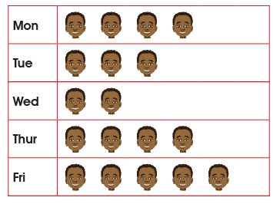  4 pupils are absent and 36 are present. | Linking the Previous knowledge to the new lesson
Step 2  Development  (5 minutes)  Grouping | 1. Groups the learners into four groups – A, B, C, and D.  2. Guide the learners to choose a leader and secretary for your group.  3. Gives each group learning materials – chart showing pupils absent. | 1. Belong to a group.  2. Choose their leader and secretary.  3. Received learning materials for their group. | Learner’s group, leader and secretary confirmed.
Step 3  Development – Groups Activities  (10 minutes) | Guides pupils to copy and complete the following.  2. The day pupils were least absent was _______  3. The day pupils were most absent was _______  4. Same number of pupils were absent on _______ and _______  5. The day most pupils were present was _______  6. The day least pupils were present was _______ | 2. 5  3. Friday  4. Monday and Thursday  5. Wednesday  6. 25 | Interpreting Pictogram
Step 4  Development - Groups Activities  (10 minutes) | 7. Pupils were _______ present on Tuesday.  8. Pupils were _______ present on Monday and Thursday.  9. The total number of times pupils were absent from Monday to Friday were _______  10. The total number of times pupils were present from Monday to Friday were _______ |  | Groups work – Interpreting Pictogram
Step 5  Development – Groups Presentation  (10 minutes) | Asks each group to present their results/solutions so that you can compare responses with those in other groups. | Presentation - Call on any member of at least two pairs in each to make presentation to the class. | Group Presentation
Step 6  Conclusion  (5 minutes) | To conclude the lesson, the teacher revises the entire lesson and ask the key questions. | The learners listen, ask and answer questions. | Lesson Evaluation and Conclusion

Reference book – New Method Mathematics

