LESSON DEVELOPMENT THREE

INTERPRETATION OF PICTOGRAM

STAGE/TIME | TEACHER’S ACTIVITIES | LEARNER'S ACTIVITIES – MIND/HANDS ON | LEARNING POINTS
Step 1  Introductory Activities  (5 minutes) | Checks their assignment to find out the month of their birth.  Lets each of them know the month they are born.    Present the months of their birth on chart by drawing the pupils. | Month of birth –  January  February  March  April  May  June  July  August  September  October  November  December | Linking the Previous knowledge to the new lesson
Step 2  Development – Grouping  (5 minutes) | 1. Groups the learners into four groups – A, B, C, and D.  2. Guide the learners to choose a leader and secretary for your group.  3. Gives each group learning materials – chart showing the month of birth. | 1. Belong to a group.  2. Choose their leader and secretary.  3. Received learning materials for their group. | Learner’s group, leader and secretary confirmed.
Step 3  Development – Pupil’s Activities  (5 minutes) | Asks the pupils –  1. How many pupils were born in January, February, etc.?  2. In which month was the highest number of pupils born? | Mind on Activities | Introduction to pictogram
Step 4  Development – Pupil’s Activities  (20 minutes) | Guides the pupils to answer the questions –  1. How many pupils were born in January, February, etc.?  2. In which month was the highest number of pupils born?  3. What is the total number of pupils born in September, October and December?  4. How many girls and boys are in Primary 1?  5. What is the total number of pupils in Primary 1? | 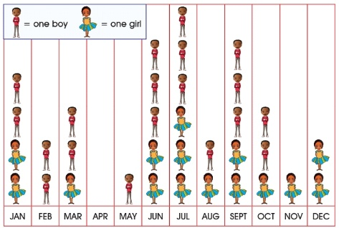  The pictogram below shows the number of pupils in Primary 1 according to the month of their birth. | Interpretation of pictogram
Step 6  Conclusion  (5 minutes) | To conclude the lesson, the teacher revises the entire lesson and ask the key questions. | The learners listen, ask and answer questions. | Lesson Evaluation and Conclusion

Reference book – New Method Mathematics Book

