LESSON DEVELOPMENT FOUR

INTERPRETATION OF PICTOGRAM II

STAGE/TIME | TEACHER’S ACTIVITIES | LEARNER'S ACTIVITIES – MIND/HANDS ON | LEARNING POINTS
Step 1  Introductory Activities  (5 minutes) | Asks the pupils to count the total of boys and girls on the chart. | The pictogram below shows the number of boys and girls in Ajeromi Nursery and Primary School.  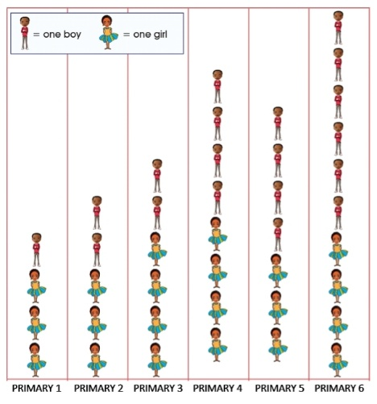 | Linking the Previous knowledge to the new lesson
Step 2  Development – Grouping  (5 minutes) | 1. Groups the learners into four groups – A, B, C, and D.  2. Guides the learners to choose a leader and secretary for your group.  3. Gives each group learning materials – chart showing the number of boys and girls in different classes. | 1. Belong to a group.  2. Choose their leader and secretary.  3. Received learning materials for their group. | Learner’s group, leader and secretary confirmed.
Step 3  Development – Pupil’s Activities  (20 minutes) | Guides the pupils to answer the following questions –  1. How many pupils are in Primary 1, 2, 3,…?  2. How many boys are in all the classes?  3. How many girls are in all the classes?  4. What is the total number of pupils in Ajeromi Nursery and Primary School?  5. Which of the class has the highest number of pupils in Ajeromi Nursery and Primary School?  6. How many boys and girls in primary 1? | The pictogram below shows the number of boys and girls in Ajeromi Nursery and Primary School. | Introduction to pictogram
Step 4  Conclusion  (10 minutes) | To conclude the lesson, the teacher revises the entire lesson and ask the key questions.  SUMMARY  Information or data collection can be represented using pictures. This is called a pictogram. | The learners listen, ask and answer questions.  KEY QUESTIONS  Leads the pupils to other classes to count the total number male and female teachers their school. | Lesson Evaluation and Conclusion

Reference book – New Method Mathematics Book

