LESSON DEVELOPMENT ONE

READING AND INTERPRETING PICTOGRAM

STAGE/TIME | TEACHER’S ACTIVITIES | LEARNER'S ACTIVITIES – MIND/HANDS ON | LEARNING POINTS
Step 1  Introductory Activities  (15 minutes) | Guides and asks pupils the following questions based on the chart.  1. Who rears the highest number of goats?  2. Who rears the smallest number of goats?  3. How many goats do Ope and Emeka and Danladi have altogether? | The pictogram below shows the number of goats owned by four (4) boys.  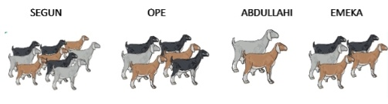  4. Find the difference between the number of goats Segun and Abdullahi has.  5. What is the total number of goats owned by the four boys? | Linking the Previous knowledge to the new lesson
Step 2  Development – Grouping  (5 minutes) | 1. Groups the learners into four groups – A, B, C, and D.  2. Guide the learners to choose a leader and secretary for your group.  3. Gives each group learning materials – chart showing pictograms. | 1. Belong to a group.  2. Choose their leader and secretary.  3. Received learning materials for their group. | Learner’s group, leader and secretary confirmed.
Step 3  Development – Pupil’s Activities  (15 minutes) | Asks the pupils use the pictogram to answer the following questions.  a) Who has the highest number of birds?  b) Who has the smallest number of birds?  c) How many more birds does Lekan have than Chidi?  d) Whose birds is two times the number of birds owned by Quadri?  e) Whose birds is one-half the number of birds owned by Bisola? | 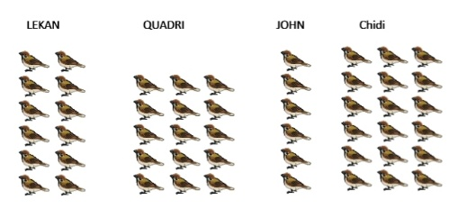  The pictogram below shows the number of birds owned by 5 children.  f) How many birds do Quadri and John have altogether?  g) How many birds do the children have altogether? | Reading and Interpreting pictogram
Step 4  Conclusion  (5 minutes) | To conclude the lesson, the teacher revises the entire lesson and ask the key questions. | The learners listen, ask and answer questions. | Lesson Evaluation and Conclusion

Reference book – New Method Mathematics Book

