LESSON DEVELOPMENT ONE

CONDUCTORS AND NON CONDUCTORS

STAGE/TIME | TEACHER’S ACTIVITIES | LEARNER'S ACTIVITIES – MIND/HANDS ON | LEARNING POINTS
Step 1  Introduction – Introductory Activities  (5 minutes) | Guides and asks the pupils to differentiate between static and current electricity. | In static electricity, electricity does move. While in current electricity, electricity from one point to another through copper wire and other conductors. | Linking the Previous knowledge to the new lesson
Step 2  Development  (5 minutes)  Grouping | 1. Groups the learners into four groups – A, B, C, and D.  2. Guide the learners to choose a leader and secretary for your group.  3. Gives each group learning materials – A battery, a bulb, adhesive tape, pieces of cardboard or plywood, paper clips or drawing pins, lengths of copper wire, cotton thread, a thin iron rod,… | 1. Belong to a group.  2. Choose their leader and secretary.  3. Received learning materials for their group.  Other materials – a long strip of paper, candle wax shaped into a long thin rod, a strip of aluminum foil, your science notebook, biro. | Learner’s group, leader and secretary confirmed.
Step 3  Development – Groups Activities  (5 minutes) | Guides the pupils set up the battery, bulb and copper wire so that the bulb lights.  Lets them replaced the wire with thread and asks them – Does the bulb light for each of them? | 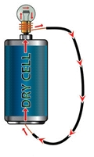  No, the bulb doesn’t light. | Activities on conductor and non conductor
Step 4  Development - Groups Activities  (10 minutes) | Asks the pupils to do the same with each of the materials you have collected, one at a time.  Does the bulb light for each of them? Tick the box if the light on or light not on. | 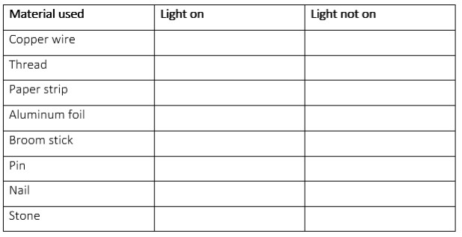 | Groups work
Step 5  Development – Groups Presentation  (10 minutes) | Asks each group to present their results/solutions so that you can compare responses with those in other groups. | Presentation - Call on any member of at least two pairs in each to make presentation to the class. | Group Presentation
Step 6  Conclusion  (10 minutes) | To conclude the lesson, the teacher revises the entire lesson and ask the key questions.  SUMMARY  All light on materials are called electric conductors or electric carriers. While all light not on materials are called non conductors. | The learners listen, ask and answer questions.  KEY QUESTIONS  What is the different between electric conductor and non conductor? | Lesson Evaluation and Conclusion

Reference book – Basic Science & Technology

