LESSON DEVELOPMENT TWO

SOURCE OF ELECTRICITY

STAGE/TIME | TEACHER’S ACTIVITIES | LEARNER'S ACTIVITIES – MIND/HANDS ON | LEARNING POINTS
Step 1  Introduction – Introductory Activities  (5 minutes) | Asks the pupils to differentiate (with examples) between electric conductors and non conductors. | Electric conductors are called electric carriers. For example are copper wire, iron, aluminum, etc.  While non conductors are non electric carriers. They include – paper, thread, etc. | Linking the Previous knowledge to the new lesson
Step 2  Development – Grouping  (5 minutes) | 1. Groups the learners into four groups – A, B, C, and D.  2. Guide the learners to choose a leader and secretary for your group.  3. Gives each group learning materials – chart showing different source of electricity. | 1. Belong to a group.  2. Choose their leader and secretary.  3. Received learning materials for their group. | Learner’s group, leader and secretary confirmed.
Step 3  Development – Groups Activities  (5 minutes) | Asks the pupils to study the chart carefully and identify different source of electricity.  Tells them any one they cannot identify or the ones identified wrongly. | 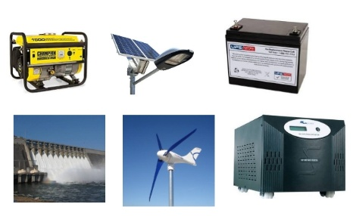 | Source of electricity
Step 4  Development - Groups Activities  (15 minutes) | Discusses with the pupils each source of electricity and asks them to state the source of energy that enable the source of electricity produce electricity. | Generator – chemical and mechanical energy.  Solar power – sun  Hydro power – water energy  Wind power – wind energy  Inverter – electrical or chemical (if it is using battery) energy. | Groups work
Step 5  Development – Groups Presentation  (10 minutes) | Asks each group to present their results/solutions so that you can compare responses with those in other groups. | Presentation - Call on any member of at least two pairs in each to make presentation to the class. | Group Presentation
Step 6  Conclusion  (15 minutes) | To conclude the lesson, the teacher revises the entire lesson and ask the key questions.  SUMMARY  There are different source of electricity. They include – generator, solar power, wind power, hydro power, inverter, etc. | The learners listen, ask and answer questions.  KEY QUESTIONS (ASSIGNMENT)  Find out the main source of electricity in Nigeria. | Lesson Evaluation and Conclusion

Reference book – Basic Science & Technology

