COMPUTER STUDIES (INFORMATION TECHNOLOGY)
BASIC SCIENCE AND TECHNOLOGY
FIRST TERM
WEEK 9
PRIMARY 1
THEME: INFORMATION TECHNOLOGY
PREVIOUS LESSON - DRAWING COMPUTER MONITOR
TOPIC - Keyboard and Mouse
PERFORMANCE OBJECTIVES
By the end of the lesson, the pupils should have attained the following objectives (cognitive, affective and psychomotor) and should be able to identify, describe and the monitor.
INSTRUCTIONAL MATERIALS
The teacher will teach the lesson with the aid of Charts. Pictures. Flash cards. Mouse. Printer. Speakers. Plain paper. Colour pencil. Keyboard. Monitor. System unit.
METHOD OF TEACHING - Choose a suitable and appropriate methods for the lessons.
Note – Irrespective of choosing methods of teaching, always introduce an activities that will arouse pupil’s interest or lead them to the lessons.
REFERENCE MATERIALS
- Scheme of Work
- 9 - Years Basic Education Curriculum
- Course Book
- All Relevant Material
- Online Information

Share and like our Facebook page or Twitter.
Related Posts

CONTENT OF THE LESSON
IDENTIFICATION OF PARTS OF A COMPUTER

KEYBOARD
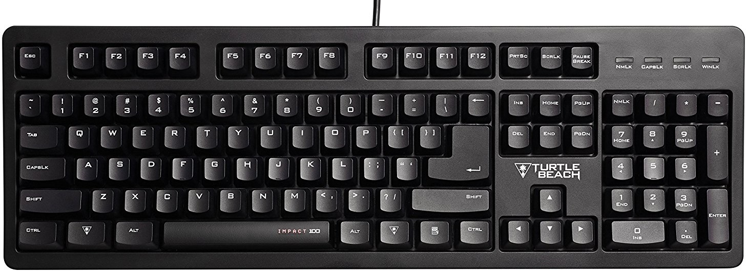

MOUSE
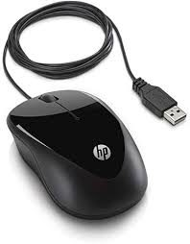

PRESENTATION
- To deliver the lesson, the teacher adopts the following steps:
- To introduce the lesson, the teacher revises the previous lesson. Based on this, he/she asks the pupils some questions;
- Asks the pupils to identify computer keyboard and mouse.
- Pupil’s Activities - Identify computer keyboard and mouse.
- Guides the pupils to drawing and color Computer keyboard and mouse.
- Pupil’s Activities - Draw and colour the pictures of the identified parts - computer keyboard and mouse.

CONCLUSION
- To conclude the lesson for the week, the teacher revises the entire lesson and links it to the following week’s lesson.
- Next Lesson - Revision.
LESSON EVALUATION
Pupils to draw computer keyboard and mouse.

