LESSON DEVELOPMENT TWO

CHANGE AROUND US – TEMPORARY AND PERMANENT CHANGE

STAGE/TIME | TEACHER’S ACTIVITIES | LEARNER'S ACTIVITIES – MIND/HANDS ON | LEARNING POINTS
Step 1  Introduction  (5 minutes) | INTRODUCTORY ACTIVITIES –  1. Asks the pupils if they have ever heard of the word ‘temporary’ before.  2. Asks if they can think of something that can be easily changed back to what it was?  3. Now ask if they know what a permanent change is.  4. Guides their thoughts by giving some examples; e.g. baby to child, raw meat to cooked meat etc.  5. Tell pupils that in today’s lesson, we will be learning about temporary and permanent changes. | MIND/HANDS ON ACTIVITIES  1. Yes/No  2. Melting butter, melting ice cubes, drying clothes etc.  Yes/No  Listen to the teacher and support teacher’s examples with more examples. | Linking the Previous knowledge to the new lesson
Step 2  Development  (5 minutes)  Grouping | 1. Groups the learners into four groups – A, B, C, and D.  2. Guide the learners to choose a leader and secretary for your group.  3. Gives each group learning materials –  Cardboard and writing materials. A candle and dry cloth. | 1. Belong to a group.  2. Choose their leader and secretary.  3. Received learning materials for their group. | Learner’s group, leader and secretary confirmed.
Step 3  Development  (5 minutes) | 1. Takes a small piece of dry cloth, walk around the class with the cloth and ask pupils to touch and feel the cloth. Let them confirm that it is dry.  2. Wets the cloth with some water. Then ask pupils to say what has changed.  3. Asks them if it can be changed back to the same dry piece of cloth they touched before. If yes, asks how?  4. Explains that this kind of change is called temporary change because we can get the cloth back to its original state before the change. | 1. Confirm that the cloth is dry.  2. The cloth has become wet cloth.  3. Yes. The cloth can become dry again when spread in the sun.  Listen to the teacher’s explanation. | Temporary change
Step 4  Development  (5 minutes) | 1. Asks pupils to light the candle and to observe the candle while burning.  Safety caution: Be careful of the fire when you or the pupils light the candles.  2. Asks them to discuss what will happen if they let the candle burn.  3. Asks the pupils if they can get the candle back again after it has burnt.  4. Explains to pupils that they cannot get the candle back to the same position once it has burnt. Tells them that this kind of change is called a permanent change.  5. Asks them, what is permanent change? | 1. The group’s leader in each group light the candle in their group.  2. The candle will melt down.  3. No.  4. Listen to the teacher’s explanation.  5. Permanent change is a change that cannot reversed. | Permanent change
Step 5  Development  (5 minutes) | Asks each group to differentiate between temporary and permanent change.  Give two examples to backup their explanations. | Groups discussion. | Temporary and permanent change
Step 6  Development  (10 minutes) | Asks each group to present their answers so that you can compare responses with those of other groups. | Presentation | Presentation
Step 7  Conclusion  (5 minutes) | To conclude the lesson, the teacher revises the entire lesson and ask the key questions.  KEY QUESTIONS  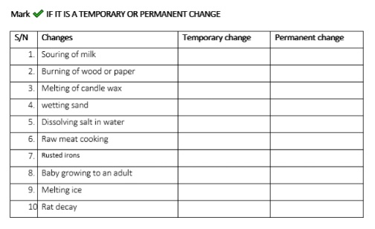 | The learners listen, ask and answer questions.  ANSWERS  1. Permanent change, 2. Permanent change, 3. Temporary change, 4. Temporary change, 5. Temporary change, 6. Permanent change | Lesson Evaluation and Conclusion

