LESSON DEVELOPMENT TWO

EFFECTS OF POLLUTION

STAGE/TIME | TEACHER’S ACTIVITIES | LEARNER'S ACTIVITIES – MIND/HANDS ON | LEARNING POINTS
Step 1  Introduction  (5 minutes) | INTRODUCTORY ACTIVITIES –  Asks pupils to mention the different types of pollution. | MIND/HANDS ON ACTIVITIES  Types of Pollution – water, air and land pollution. | Linking the Previous knowledge to the new lesson
Step 2  Development  (5 minutes)  Grouping | 1. Groups the learners into four groups – A, B, C, and D.  2. Guide the learners to choose a leader and secretary for your group.  3. Gives each group learning materials –  Pieces of paper, matches, clean bottle of water and dirt from outside. | 1. Belong to a group.  2. Choose their leader and secretary.  3. Received learning materials for their group. | Learner’s group, leader and secretary confirmed.
Step 3  Development  (5 minutes) | 1. Takes the pupils outside the class.  2. Asks them where are the dirtiest and cleanest places around the school?  3. Asks pupils, what are the made up of dirty environment?  4. Leads them back to the classroom. | 1. Follow the teacher’s lead.  2. Locate the dirtiest and cleanest places around the school.  3. The dirty water breed flies – mosquitoes, etc. The land is filled with different harmful materials life broken bottles, chair and table with nails, burning materials, etc. The air is filled with dust and smoke. | Clean and dirty environment
Step 4  Development  (10 minutes) | State two effects of pollution.  1. Smoke makes us cough. It has bad effect on the weather Inhaling (breathing in) poisonous gas can cause death.  2. Chemical waste is harmful to humans and fish. This has made a lot of fishermen jobless. You can’t use it for swimming. | Groups discussion –  3. Flies visit faeces left in the bush.  4. Old vehicles, refrigerators may injure child if abandoned in play areas.  5. Refuse dumped at road sides can cause accidents | Groups work – Effects of pollution
Step 5  Development  (10 minutes) | Asks each group to present their answers so that you can compare responses with those of other groups. | Presentation | Presentation
Step 6  Conclusion  (10 minutes) | To conclude the lesson, the teacher revises the entire lesson and ask the key questions.  KEY QUESTIONS  Copy and complete the table.  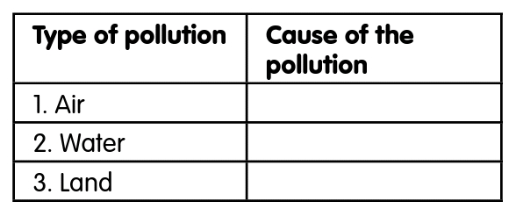 | The learners listen, ask and answer questions.  ANSWERS  Causes of pollution  1. Air  A. Smoking cigarette  B. Burning rubbish  2. Water  A. Washing clothes in the river.  B. Putting kerosene into water.  3. Land  A. Dumping of furniture on the road.  B. Using the bush as a toilet. | Lesson Evaluation and Conclusion

