LESSON DEVELOPMENT ONE

READING AND WRITING NUMBERS UP TO ONE MILLION IN WORDS

STAGE/TIME | TEACHER’S ACTIVITIES | LEARNER'S ACTIVITIES – MIND/HANDS ON | LEARNING POINTS
Step 1  Introduction  (5 minutes) | Ask and guide pupils to read 1 to 20 in words.  Make a chart of what the pupils are reading. Note – Prepare the chart before the lesson.  Tell pupils that today’s lesson will reading and writing number in words. | One – 1, Two – 2, Three – 3, Four – 4, Five – 5, Six – 6, Seven – 7, Eight – 8, Nine – 9, Ten – 10.  Eleven – 11, Twelve – 12, Thirteen – 13, Fourteen – 14, Fifteen – 15, Sixteen – 16, Seventeen – 17, Eighteen – 18, Nineteen – 19, Twenty – 20.  Listen to the teacher as he/she introduced the lesson. | Linking the Previous knowledge to the new lesson
Step 2  Development  (5 minutes)  Grouping | 1. Groups the learners into four groups – A, B, C, and D.  2. Guide the learners to choose a leader and secretary for your group.  3. Gives each group learning materials – Number Chart (Words and Figures). | 1. Belong to a group.  2. Choose their leader and secretary.  ,  3. Received learning materials for their group. | Learner’s group, leader and secretary confirmed.
Step 3  Development  (5 minutes) | Lead the pupils to read number in 10s up to 100.  Make a chart of what they are reading. Note – Prepare the chart before the lesson.  Guide pupils to continue the reading in 100s up to one million.  Tell pupils that the more the digits number, the higher the value of the number. These are the value of any number –  One digit – Unit | Ten – 10, Twenty – 20, Thirty – 30, Forty – 40, Fifty – 50, Sixty – 60, Seventy – 70, Eighty – 80, Ninety – 90, Hundred – 100.  One hundred, two hundreds, three hundreds, four hundreds, etc.  Two digits – Ten(s)  Three digits – Hundred(s)  Four digits – Thousand(s)  Five digits – Ten Thousands  Six digits – Hundreds Thousands  Seven digits – One Million, etc. | Reading Numerals in words up to one million and place value.
Step 4  Development  (5 minutes) | Remind the pupils that numbers are formed when two or more basic digit numbers are put together. Numbers can be more than one. For today’s lesson, we are going to be learning numbers up to 7 digits – one Million.  Before writing numbers in words, take note of the number of digits. If the digits is more 3, put a space or comma in the number, three digits from the right and treat each part like a separate number. | Listen to the teacher’s explanations.
Step 5  Development  (5 minutes) | Working Example  Read and write in words – 7152496  Guided Instructions  1. Identify the number of digits in 7152496.  2. Use a space or comma to group the digits number in 3 digits each (from the right hand side). | 1. There are 7 digits in 7152496.  2. 7 152 496 or 7,152,496  6 – Six  96 – 90 + 6 – Ninety six  496 – 400 + 90 + 6 – Four hundreds and ninety six  2, 496 – 2, 000 + 400 + 90 + 6 – Two thousands, four hundreds and ninety six  52, 496 – 52, 000 + 400 + 90 + 6 – Fifty two thousands, four hundreds and ninety six.  152, 492 – 152, 000 + 400 + 90 + 6 – One fifty two thousands, four hundreds, ninety six.  7, 152, 496 – 7, 000, 000 + 152, 000 + 400 + 90 + 6 – Seven millions, one fifty two thousands, four hundreds, ninety six. | Working Example
Step 6  Development  (10 minutes) | Write each number in words.  1. 454485  2. 4145886 | Groups work | Groups Evaluation
Step 7  Development  (5 minutes) | Asks each group to present their answers so that you can compare responses with those of other groups. | Presentation | Presentation
Step 8  Conclusion  (5 minutes) | To conclude the lesson, the teacher revises the entire lesson and ask the key questions.  KEY QUESTIONS – ASSIGNMENT  Write each number in words  1. 3  2. 33  3. 133  4. 2, 133  5. 82, 133  6. 182, 133  7. 5, 182, 133 | The learners listen, ask and answer questions. | Lesson Evaluation and Conclusion

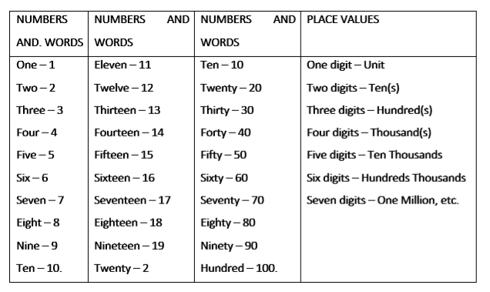
INSTRUCTIONAL MATERIALS
