LESSON DEVELOPMENT THREE

COUNTING AND WRITING OF NUMBERS IN 50s, 100s AND 200s

STAGE/TIME | TEACHER’S ACTIVITIES | LEARNER'S ACTIVITIES – MIND/HANDS ON | LEARNING POINTS
Step 1  Introduction  (5 minutes) | Lead pupils to read and write from 490 to 500. | ______, ______, ______, ______,______. 999, 1000. | Linking the Previous knowledge to the new lesson
Step 2  Development  (5 minutes)  Grouping | 1. Groups the learners into four groups – A, B, C, and D.  2. Guide the learners to choose a leader and secretary for your group.  3. Gives each group learning materials – Number Chart | 1. Belong to a group.  2. Choose their leader and secretary.  3. Received learning materials for their group. | Learner’s group, leader and secretary confirmed.
Step 3  Development  (10 minutes) | Ask the group to count the number square on the chart.  Lead and guide pupils to read and write in 50s up 500. | 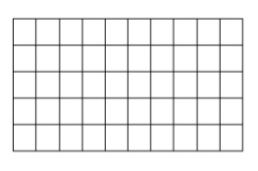  50, 100, 150, 200, 250, 300, 350, 400, 450, 500. | Counting from 500.
Step 4  Development  (10 minutes) | Repeat the activities on counting in 100 and 200. | Work in progress | Group work
Step 6  Development | Asks each group to present their answers so that you can compare responses with those of other groups. | Presentation | Presentation
Step 7  Conclusion  (10 minutes) | To conclude the lesson, the teacher revises the entire lesson and ask the key questions.  KEY QUESTIONS – ASSIGNMENT  Copy and complete the from – | The learners listen, ask and answer questions. | Lesson Evaluation and Conclusion

