LESSON DEVELOPMENT ONE

IDENTIFICATION OF NUMBERS OF OBJECTS 1 - 5

STAGE/TIME | TEACHER’S ACTIVITIES | LEARNER'S ACTIVITIES – MIND/HANDS ON | LEARNING POINTS
Step 1  Introduction  (5 minutes) | Display 5 objects on pupil’s desk for identification. | Objects of identification –  Pencils  Biro  Books  Ruler  Bottle tops | Linking the Previous knowledge to the new lesson
Step 2  Development  (5 minutes)  Grouping | 1. Groups the learners into four groups – A, B, C, and D.  2. Guide the learners to choose a leader and secretary for your group.  3. Gives each group learning materials – 5 Countable objects, 16 each. 5 different sizeable cardboards with number 1 to 5. | 1. Belong to a group.  2. Choose their leader and secretary.  3. Received learning materials for their group. | Learner’s group, leader and secretary confirmed.
Step 3  Development  (10 minutes) | Display the number charts on the pupil’s desk or wide tables.  Put an object on each cardboard to represent the card number. For example – chart number 1, put one pencil, chart number 2, put 2 books, etc.  Pick an object and ensure that pupils can sort objects that are similar to the object picked on the cards.  Lead pupils to identify objects according to the number in each group as well. | Paying attention to the teacher’s activities.  Identifying objects according to the number in each group. | Identification of Number of Objects
Step 4  Development  (10 minutes) | Tell pupils to look at charts and ask how many –  Pencil?  Books?  Biro?  Seeds?  Bottle tops?  Let them say it aloud. | Pupil’s responses are depend on the chart number. | Identification of Number of Objects
Step 6  Development | Asks each group to present their answers so that you can compare responses with those of other groups. | Presentation | Presentation
Step 7  Conclusion  (10 minutes) | To conclude the lesson, the teacher revises the entire lesson and ask the key questions.  KEY QUESTIONS – ASSIGNMENT  Guide pupils identify the number of objects.  Ask them say the number aloud. | The learners listen, ask and answer questions.  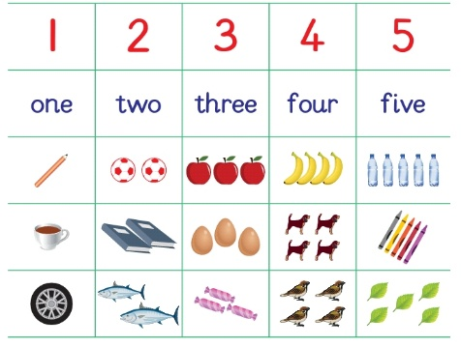 | Lesson Evaluation and Conclusion

