LESSON DEVELOPMENT THREE

READ NUMBER OF OBJECTS 1 - 5

STAGE/TIME | TEACHER’S ACTIVITIES | LEARNER'S ACTIVITIES – MIND/HANDS ON | LEARNING POINTS
Step 1  Introduction  (5 minutes) | Display chart with things that come in One’s, Twos, Threes, Four’s and Five’s for pupils identification.  These are within/out the classroom or part of our body. | Identification of objects on the chart –  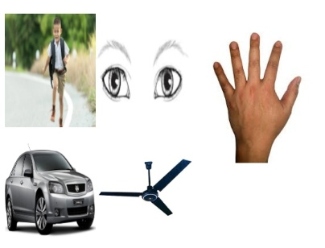  Chair, table, fan, eyes, hands, nose, mouth, car, fingers, stand, windows, doors, plants, biscuits, etc. | Linking the Previous knowledge to the new lesson
Step 2  Development  (5 minutes)  Grouping | 1. Groups the learners into four groups – A, B, C, and D.  2. Guide the learners to choose a leader and secretary for your group.  3. Gives each group learning materials – Things that come in 1s, 2s, 3s, 4s and 5s. | 1. Belong to a group.  2. Choose their leader and secretary.  3. Received learning materials for their group. | Learner’s group, leader and secretary confirmed.
Step 3  Development  (15 minutes) | Guide the pupils to discover the concept of the numeral 1 using an object one at a time. Lead them to spell the number 1 in word form as one. | Pay attention to the teacher’s guidelines.  O N E – 1 Finger  T W O – 2 Fingers  T H R E E – 3 Fingers  F O U R – 4 Fingers  F I V E – 5 Fingers | Reading Number of Objects 1 - 5
Step 4  Development  (10 minutes) | Ask pupils the following questions –  How many head did you have?  How many eyes did you have?  Fan has how many hands?  A car has how many tyres?  How many fingers in a hand? | Expected answer –  1 – One head  2 – Two eyes  3 – Three hands  4 – Four tyres  5 – Five fingers | Identification of Number of Objects
Step 5  Development | 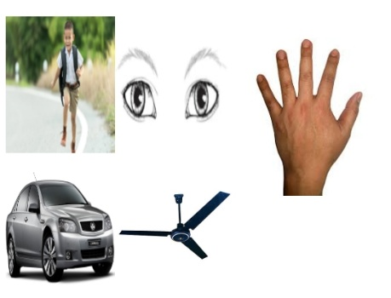
Step 6  Conclusion  (10 minutes) | To conclude the lesson, the teacher revises the entire lesson and ask the key questions.  KEY QUESTIONS – ASSIGNMENT  Guide pupils identify the number of objects.  Ask them say the number aloud. | The learners listen, ask and answer questions. | Lesson Evaluation and Conclusion

INSTRUCTIONAL MATERIALS

