LESSON DEVELOPMENT THREE

COUNTING AND WRITING OF NUMBERS IN 2s, 5s, 10s and 20s

STAGE/TIME | TEACHER’S ACTIVITIES | LEARNER'S ACTIVITIES – MIND/HANDS ON | LEARNING POINTS
Step 1  Introduction  (5 minutes) | Provide the pupils with as many as counting materials (such as beads or bottle tops) up to 100.  Lead them to count in groups of 10s inside a box. | 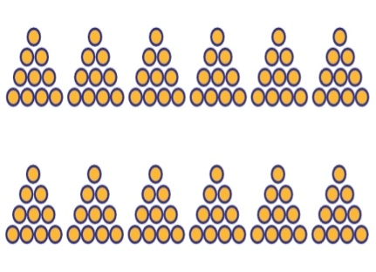 | Linking the Previous knowledge to the new lesson
Step 2  Development  (5 minutes)  Grouping | 1. Groups the learners into four groups – A, B, C, and D.  2. Guide the learners to choose a leader and secretary for your group.  3. Gives each group learning materials – counters or beads up to 100. | 1. Belong to a group.  2. Choose their leader and secretary.  3. Received learning materials for their group. | Learner’s group, leader and secretary confirmed.
Step 3  Development  (10 minutes) | Give each group a ten or 2 tens.  Guide them to group in 2s.  Let all pupils participate as each of the group counts.  Guide them in counting in 2s.  Repeat this activities in 5s. | Counting in 2s – 2, 4, 6, 8 and 10.  Counting in 5s – 5 and 10. | Counting in 2s and 10s
Step 4  Development  (10 minutes) | Put two or group to have more counters.  Guide them to group their counters in 5, then count in 5s.  Repeat this activities in 10s and 20s. | Counting in 5s – 5, 10, 15, 20, 25 and 30.  Counting in 10s – 10, 20, 30, 40, 50, 60, 70, 80, 90 and 100.  Counting in 20 – 20, 40, 80 and 100. | Counting in 10s and 20s.
Step 6  Development | Asks each group to present their answers so that you can compare responses with those of other groups. | Presentation | Presentation
Step 7  Conclusion  (10 minutes) | To conclude the lesson, the teacher revises the entire lesson and ask the key questions.  KEY QUESTIONS – ASSIGNMENT  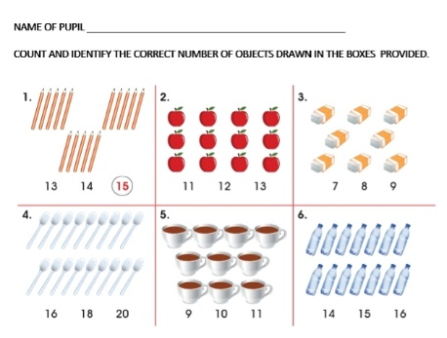 | The learners listen, ask and answer questions. | Lesson Evaluation and Conclusion
