LESSON DEVELOPMENT TWO

COUNTING AND WRITING OF NUMBERS UP TO 100

STAGE/TIME | TEACHER’S ACTIVITIES | LEARNER'S ACTIVITIES – MIND/HANDS ON | LEARNING POINTS
Step 1  Introduction  (5 minutes) | Provide the pupils with as many as counting materials (such as beads or bottle tops) up to 100.  Lead them to count in groups of 10s inside a box. | 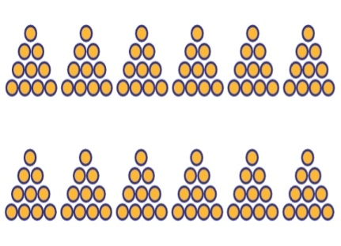 | Linking the Previous knowledge to the new lesson
Step 2  Development  (5 minutes)  Grouping | 1. Groups the learners into four groups – A, B, C, and D.  2. Guide the learners to choose a leader and secretary for your group.  3. Gives each group learning materials – counters or beads up to 100. | 1. Belong to a group.  2. Choose their leader and secretary.  3. Received learning materials for their group. | Learner’s group, leader and secretary confirmed.
Step 3  Development  (10 minutes) | Give each group a ten or 2 tens.  Lead each group to counter, one after the other. For example – group A counts from 1 to 10, group B continues counting their part from 11 to 20, up to 100  Let all pupils participate as each of the group counts. | 1, 2, 3, 4,… 10  91, 92, 93, 94,… 100 | Counting of Numbers.
Step 4  Development  (10 minutes) | Guide each group to write their own part on cardboard. | 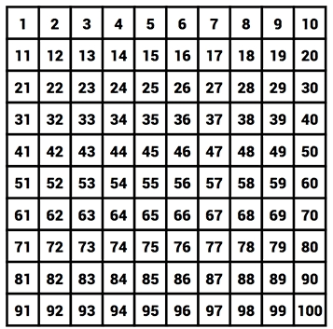 | Writing of Numbers
Step 6  Development | Asks each group to present their answers so that you can compare responses with those of other groups. | Presentation | Presentation
Step 7  Conclusion  (10 minutes) | To conclude the lesson, the teacher revises the entire lesson and ask the key questions.  KEY QUESTIONS – ASSIGNMENT  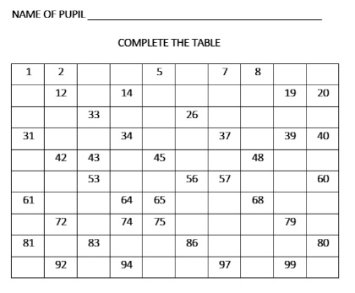 | The learners listen, ask and answer questions. | Lesson Evaluation and Conclusion

