LESSON DEVELOPMENT ONE

CHANGE IN PLANTS

STAGE/TIME | TEACHER’S ACTIVITIES | LEARNER'S ACTIVITIES – MIND/HANDS ON | LEARNING POINTS
Step 1  Introduction  (5 minutes) | Display a set of flashcards.  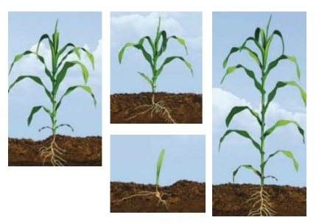  Ask them to arrange the flashcards in the right order of growth like the ones used in the introduction.  Make sure the flash cards are arranged in the correct order. | 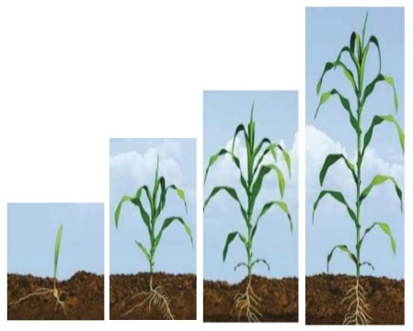 | Linking the Previous knowledge to the new lesson
Step 2  Development  (5 minutes)  Grouping | 1. Groups the learners into four groups – A, B, C, and D.  2. Guide the learners to choose a leader and secretary for your group.  3. Gives each group learning materials –  Set of flashcards showing different stages of plant. Materials for planting (bean seed, plastic cup, soil and water). | 1. Belong to a group.  2. Choose their leader and secretary.  3. Received learning materials for their group. | Learner’s group, leader and secretary confirmed.
Step 3  Development  (5 minutes) | Tell the pupils that the process of a baby growing into a child and eventually into an adult is a permanent change.  Remind pupils that change simply means “to make something different from what it was before”. | Listen to the teacher’s comments.  Remind pupils that change simply means “to make something different from what it was before”. | Meaning of change.
Step 4  Development  (15 minutes) | Tell pupils that they are going to plant a bean seed and observe it over the next few weeks.  Give out materials for planting (bean seed, plastic cup, soil and water).  Guide pupils how to plant a bean - half the cup with soil, and then put seed in the soil. Write the group name on the cup. Add a little bit of water.  Ask them to leave the cups outside for at least a week.  Note – The plant seed must be left for a week or so to germinate and produce a shoot. | Listen to the teacher’s instructions and follow it accordingly. | Bean planting
Step 5  Development  (5 minutes) | Asks each group to present their answers so that you can compare responses with those of other groups. | Presentation | Presentation
Step 6  Conclusion  (5 minutes) | To conclude the lesson, the teacher revises the entire lesson and ask the key questions. | The learners listen, ask and answer questions. | Lesson Evaluation and Conclusion

