LESSON DEVELOPMENT TWO

PLACE VALUE OF DECIMAL NUMBERS

STAGE/TIME | TEACHER’S ACTIVITIES | LEARNER'S ACTIVITIES – MIND/HANDS ON | LEARNING POINTS
Step 1  Introduction  (5 minutes) | Ask pupils to differentiate between 75 143 and 75.143.  Support their response, 75 143 is whole number while 75.143 is a decimal number. The decimal point separate the whole number from fraction.  Guide the pupils on how to read decimal number. For example – Seventy five point one, four, three. Not Seventy five points, one hundred and forty three. | Expected response –  1. The two numbers are the same.  2. The two numbers are different. Right.  Listen to the teacher’s explanation and read decimal number. | Linking the Previous knowledge to the new lesson
Step 2  Development  (5 minutes)  Grouping | 1. Groups the learners into four groups – A, B, C, and D.  2. Guide the learners to choose a leader and secretary for your group.  3. Gives each group learning materials – Place value chart of decimal numbers. | 1. Belong to a group.  2. Choose their leader and secretary.  3. Received learning materials for their group. | Learner’s group, leader and secretary confirmed.
Step 3  Development  (5 minutes) | Tell pupils that different between place value of whole numbers and decimal numbers.  The first digit of any whole numbers start from the right (Unit) while the first digit of any decimal numbers start from the left (tenth).  Place the place value of whole numbers and decimal numbers on the board. | 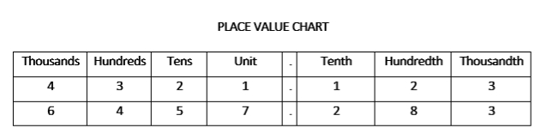 | Identification of place value of whole numbers and decimal numbers
Step 4  Development  (5 minutes) | Guide the groups to identify and expand each digit on the chart.  1. 4 321.123 | 4000 – 4 Thousands  300 – 3 Hundreds  20 – 2 Tens  1 – Unit  Point  1 – 1/10 – Tenth  2 – 2/100 – Hundredth  3 – 3/1000 – Thousandth | Place value of whole numbers and decimal numbers
Step 4  Development  (10 minutes) | Find the place value of each digit in this number – 6457.283 | Groups work | Groups Evaluation
Step 5  Development  (5 minutes) | Asks each group to present their answers so that you can compare responses with those of other groups. | Presentation | Presentation
Step 6  Conclusion  (5 minutes) | To conclude the lesson, the teacher revises the entire lesson and ask the key questions. | The learners listen, ask and answer questions. | Lesson Evaluation and Conclusion

