LESSON DEVELOPMENT ONE

PLACE VALUE OF WHOLE NUMBERS AND DECIMAL NUMBERS

STAGE/TIME | TEACHER’S ACTIVITIES | LEARNER'S ACTIVITIES – MIND/HANDS ON | LEARNING POINTS
Step 1  Introduction  (5 minutes) | Lead the pupils to count aloud from 1 to 100 000 in the following patterns –  1  10  100  1 000  10 000  100 000  1 000 000  Tell them to count the number of digits in each number.  Ask the pupils the great number because 1 and 10, 10 and 100, 100 and 1 000, 1 000 and 10 000, 10 000 and 100 000, 100 000 and 1 000 000.  Then, let them know that the number of digits, the more the value of that number.  In today’s lesson, you will be learning Place Value of Numbers. | Follow the teacher’s lead and count.  Number of digits  One digit number  Two digits number  Three digits number  Four digits number  Five digits number  Six digits number  Seven digits number  1 000 000 > 100 000 > 10 000 > 1 000 > 100 > 10 > 1. | Linking the Previous knowledge to the new lesson
Step 2  Development  (5 minutes)  Grouping | 1. Groups the learners into four groups – A, B, C, and D.  2. Guide the learners to choose a leader and secretary for your group.  3. Gives each group learning materials – Place value chart up to 1 000 000 for each group. | 1. Belong to a group.  2. Choose their leader and secretary.  3. Received learning materials for their group. | Learner’s group, leader and secretary confirmed.
Step 3  Development  (5 minutes) | Place the chart of place value of numbers on the board.  Tell the pupils that each box represents a digit.  Guide them to place each digit of the number counted in step 1 on the chart. | 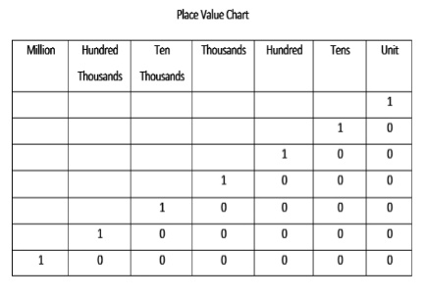 | Counting form 10 000 up to 100 000
Step 4  Development  (5 minutes) | Tell pupils that, 1 has one digit and one value called one or unit. 10 has two digits and two values – it is the 2nd digit that Ten while the first digit is Unit from the right hand side.  Write 100 on the board and ask, what number is this?  Correct, hundred is the value of the 3rd digit while 2nd and 1st is Ten and Unit.  Continue with this until you reach 1 000 000. | Listen to the teacher’s explanation.  Pupil’s response – Hundred.  Listen to the teacher’s explanation.
Step 4  Development  (10 minutes) | Give each group a plain place value chart and their questions - What is the place-value of 7 in these numbers?  1. 7 001 432  2. 1 107 001  3. 7 689 114  4. 9 007 453  6. 1 652 745 | Groups work  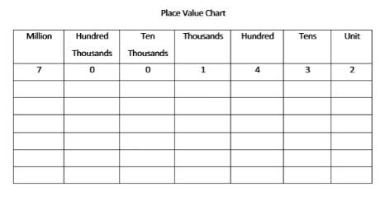 | Groups Evaluation
Step 5  Development  (5 minutes) | Asks each group to present their answers so that you can compare responses with those of other groups. | Presentation | Presentation
Step 6  Conclusion  (5 minutes) | To conclude the lesson, the teacher revises the entire lesson and ask the key questions. | The learners listen, ask and answer questions. | Lesson Evaluation and Conclusion

