LESSON DEVELOPMENT TWO

IDENTIFICATION AND READING OF NUMBERS 101 - 200

STAGE/TIME | TEACHER’S ACTIVITIES | LEARNER'S ACTIVITIES – MIND/HANDS ON | LEARNING POINTS
Step 1  Introduction  (5 minutes) | Lead the pupils to count numbers from 101 to 200. | 101, 102, 103, up to 200. | Linking the Previous knowledge to the new lesson
Step 2  Development  (5 minutes)  Grouping | 1. Groups the learners into four groups – A, B, C, and D.  2. Guide the learners to choose a leader and secretary for your group.  3. Gives each group learning materials – Number Chart | 1. Belong to a group.  2. Choose their leader and secretary.  3. Received learning materials for their group. | Learner’s group, leader and secretary confirmed.
Step 3  Development  (10 minutes) | Call a number at random and ask pupil identify the number on the chart.  Point to a number at random and ask them to read the number. | 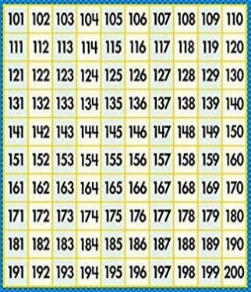 | Counting of Numbers.
Step 4  Development  (10 minutes) | Call five numbers at random for each group to identify and write down in their book. | Group activities | Group work
Step 6  Development | Asks each group to present their answers so that you can compare responses with those of other groups. | Presentation | Presentation
Step 7  Conclusion  (10 minutes) | To conclude the lesson, the teacher revises the entire lesson and ask the key questions. | The learners listen, ask and answer questions. | Lesson Evaluation and Conclusion

