LESSON DEVELOPMENT TWO

CLASSIFYING OBJECTS LEADING TO IDEA OF 1–5

STAGE/TIME | TEACHER’S ACTIVITIES | LEARNER'S ACTIVITIES – MIND/HANDS ON | LEARNING POINTS
Step 1  Introduction  (5 minutes) | Identify each of object on the chart. | 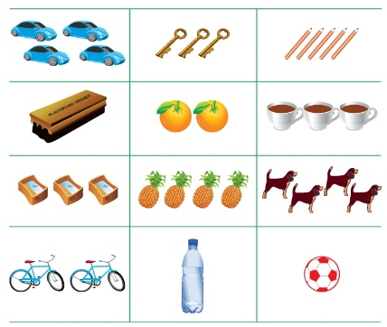 | Linking the Previous knowledge to the new lesson
Step 2  Development  (5 minutes)  Grouping | 1. Groups the learners into four groups – A, B, C, and D.  2. Guide the learners to choose a leader and secretary for your group.  3. Gives each group learning materials – 5 Countable objects, 16 each. 5 different sizeable cardboards with number 1 to 5. | 1. Belong to a group.  2. Choose their leader and secretary.  3. Received learning materials for their group. | Learner’s group, leader and secretary confirmed.
Step 3  Development  (10 minutes) | Identify objects that are similar in numbers.  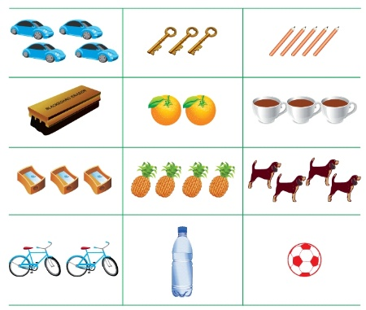 | Objects of one – bottle water, ball and duster  Objects of two – oranges and bicycles  Objects of three – keys, sharpeners and tea cups  Objects of four – cars, pineapples and dogs.  Objects of five – pencils | Objects of similar numbers
Step 4  Development  (10 minutes) | Which box has the same objects that are shown in the left column? | 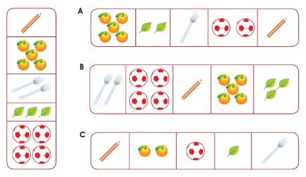 | Similar objects according to numbers.
Step 6  Development | Asks each group to present their answers so that you can compare responses with those of other groups. | Presentation | Presentation
Step 7  Conclusion  (10 minutes) | To conclude the lesson, the teacher revises the entire lesson and ask the key questions. | The learners listen, ask and answer questions. | Lesson Evaluation and Conclusion

