LESSON DEVELOPMENT ONE

SORTING OBJECTS

STAGE/TIME | TEACHER’S ACTIVITIES | LEARNER'S ACTIVITIES – MIND/HANDS ON | LEARNING POINTS
Step 1  Introduction  (5 minutes) | Display 10 different objects on pupil’s desk for identification.  Ask pupils to identify at least 6 or more the chart. | Objects of identification –  Pencils  Car  Dog  Biro  Books  Ruler  Bottle tops, etc. | Linking the Previous knowledge to the new lesson
Step 2  Development  (5 minutes)  Grouping | 1. Groups the learners into four groups – A, B, C, and D.  2. Guide the learners to choose a leader and secretary for your group.  3. Gives each group learning materials – 5 Countable objects, 16 each. 5 different sizeable cardboards with number 1 to 5. | 1. Belong to a group.  2. Choose their leader and secretary.  3. Received learning materials for their group. | Learner’s group, leader and secretary confirmed.
Step 3  Development  (10 minutes) | On the chart, ask pupils, which of the objects in the picture can you –  1. Play with  2. Use in the classroom?  2. Name the fruits shown in the pictures. | 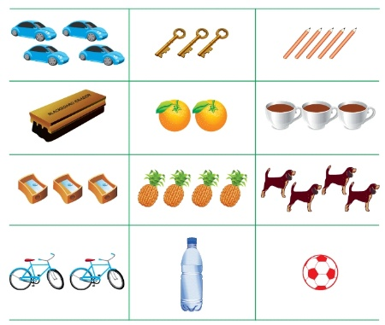  1. Ball and bicycle  2. Pencils, duster and sharpeners  3. Oranges and pineapples | Sorting out of objects
Step 4  Development  (10 minutes) | Ensure that pupils can sort objects that are similar. | 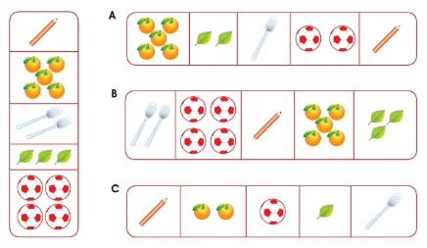 | Similar objects according to numbers.
Step 6  Development | Asks each group to present their answers so that you can compare responses with those of other groups. | Presentation | Presentation
Step 7  Conclusion  (10 minutes) | To conclude the lesson, the teacher revises the entire lesson and ask the key questions. | The learners listen, ask and answer questions. | Lesson Evaluation and Conclusion

