LESSON DEVELOPMENT ONE

CHANGE IN ANIMALS

STAGE/TIME | TEACHER’S ACTIVITIES | LEARNER'S ACTIVITIES – MIND/HANDS ON | LEARNING POINTS
Step 1  Introduction  (5 minutes) | Show pupils 2 flashcards; one showing a puppy and the other an adult dog.  Discuss the following questions with pupils: What happens when a dog grows?  Are these changes temporary or permanent? | Permanent change | Linking the Previous knowledge to the new lesson
Step 2  Development  (5 minutes)  Grouping | 1. Groups the learners into four groups – A, B, C, and D.  2. Guide the learners to choose a leader and secretary for your group.  3. Gives each group learning materials – Flash cards with pictures, markers, glue/gum, cardboard papers, plain sheets, scissors. | 1. Belong to a group.  2. Choose their leader and secretary.  3. Received learning materials for their group. | Learner’s group, leader and secretary confirmed.
Step 3  Development  (10 minutes) | Give each group one set of the flashcards (i.e. the one showing human beings or the one showing the hen).  Ask pupils to cut a plain sheet of paper into 4 equal parts and let each group draw each of the stages of growth on each small piece of paper. | 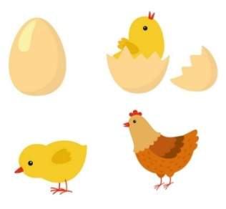 | Stages of human/chicken growth
Step 4  Development  (5 minutes) | Ask pupils to glue the small drawings onto the cardboard paper using the gum provided. The drawings should be arranged in the order in which the growth occurs.  Ask pupils to use arrows to show the correct order of development in the life cycle of the animals in their flashcards.  Go around the class to provide support for each group. Collect their drawings/posters and display around the classroom walls.  Give feedback on the activity. |  | Order of human growth
Step 5  Development  (5 minutes) | Ask pupils the following questions –  1. What changes can you see when a person grows from a baby to an adult.  2. What changes can you see when an egg hatches.  3. Are these changes permanent or temporary changes? Give reasons for your answers. | Groups work | Groups Evaluation
Step 6  Development  (5 minutes) | Asks each group to present their answers so that you can compare responses with those of other groups. | Presentation | Presentation
Step 7  Conclusion  (5 minutes) | To conclude the lesson, the teacher revises the entire lesson and ask the key questions. | The learners listen, ask and answer questions. | Lesson Evaluation and Conclusion

