LESSON DEVELOPMENT TWO

CHANGE IN ANIMALS – ANIMALS WITH THEIR YOUND ONES

STAGE/TIME | TEACHER’S ACTIVITIES | LEARNER'S ACTIVITIES – MIND/HANDS ON | LEARNING POINTS
Step 1  Introduction  (5 minutes) | Show pictures of different animals to the class and ask them to name the animal and also name its young. (eg. Lion and cub).  Give each group a flash card with the name of a young animal written on it.  Then, show the pictures of the different animals (one at a time) and ask the groups to look at the name on their cards and match it to the corresponding picture of the animal by raising their cards up once the picture is flashed by the teacher. If groups make a mistake, ask other groups to help out.  Repeat until all pictures are done. | 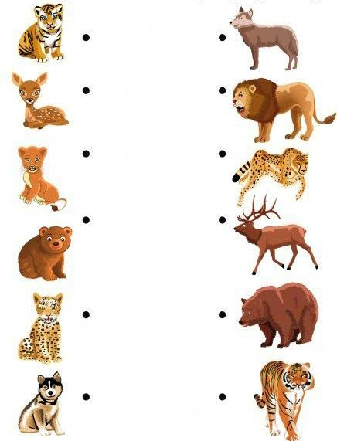 | Linking the Previous knowledge to the new lesson
Step 2  Development  (5 minutes)  Grouping | 1. Groups the learners into four groups – A, B, C, and D.  2. Guide the learners to choose a leader and secretary for your group.  3. Gives each group learning materials – A poster of animals and their young ones. Flash cards with names of all the animals and their young ones written separately. | 1. Belong to a group.  2. Choose their leader and secretary.  3. Received learning materials for their group. | Learner’s group, leader and secretary confirmed.
Step 3  Development  (10 minutes) | Tell pupils that they are going to listen to a story about animals and their young ones shortly. (The story is in the Notes for the teacher section).  Ask them to listen to the story very carefully and remember or write down the names of different types of young animals.  Now read the ‘animal story’ twice for pupils to listen; the first time with all the names in and the second time with the names of the animals (but not their young) missed out. While the pupils are listening to the story, draw the table below on the board.  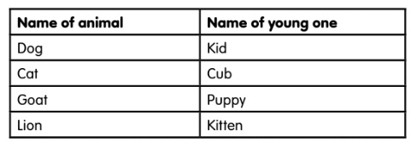 | Pupils listening to the teacher’s story. | Story on animals and names of young ones.
Step 4  Development  (5 minutes) | After listening to the story, ask pupils if they now know the names of young animals.  Now tell them to copy the table from the board on their exercise book and match the animals to their young ones.  Do one example for them – Dog, young dog – puppy.  Walk around the class to ensure that pupils are actively participating in the exercise.  After they finish, ask any four pupils to do the matching on the board. | 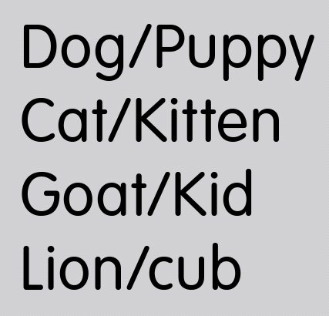 | Animals and names of young ones
Step 5  Development  (5 minutes) | Call names of animals learnt in the lesson and get pupils to mention the names of the younger ones.  Ask pupils to name 5 other animals and their young ones apart from the ones they have learnt about in today’s lesson | Groups work | Groups Evaluation
Step 6  Development  (5 minutes) | Asks each group to present their answers so that you can compare responses with those of other groups. | Presentation | Presentation
Step 7  Conclusion  (5 minutes) | To conclude the lesson, the teacher revises the entire lesson and ask the key questions. | The learners listen, ask and answer questions. | Lesson Evaluation and Conclusion

TEACHER’S NOTE
The Animal Kingdom Story
Once upon a time in the animal kingdom, Mr. and Mrs. Cow had a baby named Calf. Baby Calf liked to play with baby Piglet, but Piglet’s parents; Mr. and Mrs. Pig did not like the idea because they were afraid that when Calf and Piglet were out playing, Mr. and Mrs. Lion could come out and attack or kill them. This made Piglet and Calf very sad.
In that kingdom, there also lived Mr. and Mrs. Horse who had two babies; a baby boy named Colt and a baby girl named Foal, Mr. and Mrs. Cat who had a baby named Kitten, Mr. and Mrs. Lion who had a baby named Cub, Mr. and Mrs. Goat who had a baby named Kid and Mr. and Mrs. Dog who had a baby named Puppy.
All these animals lived peacefully except for troublesome Mr. and Mrs. Lion who would attack and sometimes kill other animals for food. So one day, all the other animals in the kingdom decided to move far away to another kingdom where they will be free from the attack of Mr. and Mrs. Lion. All the animals agreed and moved far away, leaving Mr. and Mrs. Lion alone in the kingdom.

