LESSON DEVELOPMENT THREE

CHANGE IN ANIMALS III

STAGE/TIME | TEACHER’S ACTIVITIES | LEARNER'S ACTIVITIES – MIND/HANDS ON | LEARNING POINTS
Step 1  Introduction  (5 minutes) | Show the pupils a picture of a baby girl or boy and tell them to state the differences with the adult picture. Put it in a table form as below –  Baby girl Adult woman  No teeth Teeth  Get the pupils to compare what they can see. One example has been put in the table above. | 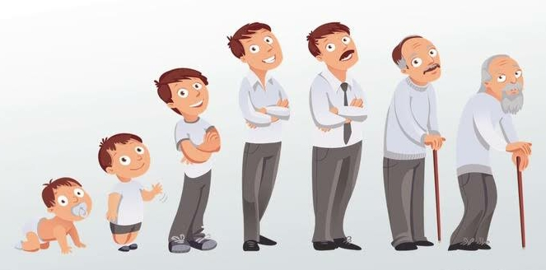 | Linking the Previous knowledge to the new lesson
Step 2  Development  (5 minutes)  Grouping | 1. Groups the learners into four groups – A, B, C, and D.  2. Guide the learners to choose a leader and secretary for your group.  3. Gives each group learning materials – Pictures of baby girl/boy and adult woman and man. Flash cards of animals and their young ones (Refer to previous lesson for pictures of animals and their young ones), poster of animals and their young ones. | 1. Belong to a group.  2. Choose their leader and secretary.  3. Received learning materials for their group. | Learner’s group, leader and secretary confirmed.
Step 3  Development  (5 minutes) | Tell the pupils that in the introduction, they looked at the differences between a baby and an adult.  Now they are going to do the same thing with some animals.  Show the class the poster of animals and their young ones. | 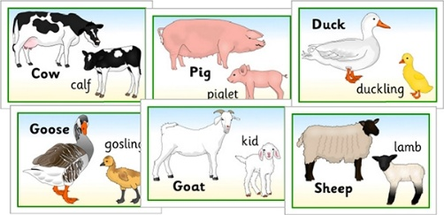 | Animals and their young ones
Step 4  Development  (10 minutes) | Give each group an animal from the poster.  Now ask them to draw a table like the one on the board.  Let each group think about the animal drawn on their flashcards and fill in the table with the differences that exist between the adult and the younger one of that animal. | Group activities | Difference that occurred between adults animals and their young ones.
Step 5  Development  (10 minutes) | Asks each group to present their answers so that you can compare responses with those of other groups.  Have one or two groups come out and share their work with the rest of the class. | Presentation | Presentation
Step 6  Conclusion  (5 minutes) | To conclude the lesson, the teacher revises the entire lesson and ask the key questions. | The learners listen, ask and answer questions. | Lesson Evaluation and Conclusion

