LESSON DEVELOPMENT THREE

CHANGING FRACTION AND DECIMAL TO PERCENTAGE AND VICE VERSA

STAGE/TIME | TEACHER’S ACTIVITIES | LEARNER'S ACTIVITIES – MIND/HANDS ON | LEARNING POINTS
Step 1  Introduction  (10 minutes) | Ask groups to confirm number of squares on the chart.  Use the square chart to introduce the meaning of percentage as 100. |  | Linking the Previous knowledge to the new lesson
Step 2  Development  (5 minutes)  Grouping | 1. Groups the learners into four groups – A, B, C, and D.  2. Guide the learners to choose a leader and secretary for your group.  3. Gives each group learning materials – chart showing 100 square box. | 1. Belong to a group.  2. Choose their leader and secretary.  3. Received learning materials for their group. | Learner’s group, leader and secretary confirmed.
Step 3  Development  (5 minutes) | What is the fraction or decimal of the colored squares?  Guide the groups to express the colored square as percentage. | 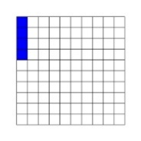  4 out 100 is colored and it is written as 4/100 or 0.04.  4 x 100 = 4%  100 | Percentage
Step 4  Development  (5 minutes) | Guide the groups convert the following percentages to fractions and decimals.  1. 70%  2. 54% | 1. To fractions  70% = 70/100 = 7/10.  To decimals  7/10 = 0.7  2. To fraction  54% = 54/100 = 27/50  To decimal  54/100 = 0.54 | Converting percentages to fractions and decimals.
Step 4  Development  (10 minutes) | Find the fractions of the colored squares on the chart.  Covert the fractions to decimals and percentages. | 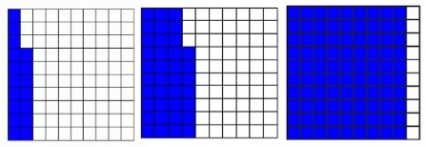 | Groups Evaluation
Step 5  Development  (5 minutes) | Asks each group to present their answers so that you can compare responses with those of other groups. | Presentation | Presentation
Step 6  Conclusion  (5 minutes) | To conclude the lesson, the teacher revises the entire lesson and ask the key questions.  KEY QUESTIONS – The groups work will be given as work to do to all the pupils. | The learners listen, ask and answer questions. | Lesson Evaluation and Conclusion

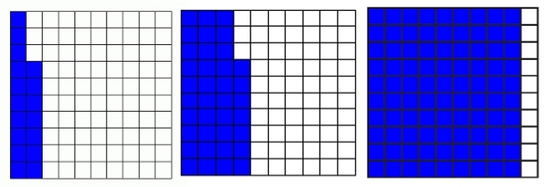
SQUARE CHART

