LESSON DEVELOPMENT ONE

COUNTING AND WRITING OF NUMBERS from 1 to 5

STAGE/TIME | TEACHER’S ACTIVITIES | LEARNER'S ACTIVITIES – MIND/HANDS ON | LEARNING POINTS
Step 1  Introduction  (5 minutes) | Ask pupils to identify and counting different number of objects present or on the chart. | Dogs – number of dogs, 5  Balls – number of balls, 3  Pencils – number of pencils, 4  Books – number of books, 2  Sharpene – number one sharpener, 1 | Linking the Previous knowledge to the new lesson
Step 2  Development  (5 minutes)  Grouping | 1. Groups the learners into four groups – A, B, C, and D.  2. Guide the learners to choose a leader and secretary for your group.  3. Gives each group learning materials – counters, number chart and flash cards | 1. Belong to a group.  2. Choose their leader and secretary.  3. Received learning materials for their group. | Learner’s group, leader and secretary confirmed.
Step 3  Development  (10 minutes) | Guide pupils to sort objects that are similar. Identify the number of each objects. | 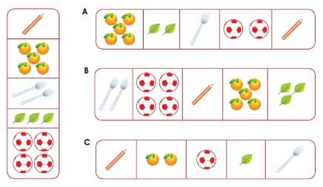 | Counting and sorting similar objects.
Step 4  Development  (10 minutes) | Ask pupils to write the number 1 to 5. | 1  2  3  4  5 | Writing of Numbers
Step 5  Conclusion  (10 minutes) | To conclude the lesson, the teacher revises the entire lesson and ask the key questions. | The learners listen, ask and answer questions. | Lesson Evaluation and Conclusion

