LESSON DEVELOPMENT ONE

MEANING AND SYMBOLS OF WEATHER

STAGE/TIME | TEACHER’S ACTIVITIES | LEARNER'S ACTIVITIES – MIND/HANDS ON | LEARNING POINTS
Step 1  Introduction  (5 minutes) | Lead the pupils to an open space (school field) where they can view the sky.  Ask them to look up and state what they can see in the sky during the day and night?  Then, introduce today’s lesson as weather and lead them back to the classroom. | Follow the teacher’s lead.  The sun, cloud, moon and stars. The rainfall, rainbow, wind, thunder or lightning, snow and so on.  Listen to the teacher’s introduction of lesson and follow he/her lead back to the classroom. | Linking the Previous knowledge to the new lesson
Step 2  Development  (5 minutes)  Grouping | 1. Groups the learners into four groups – A, B, C, and D.  2. Guide the learners to choose a leader and secretary for your group.  3. Gives each group learning materials – The school environment and chart showing the state of the atmosphere. | 1. Belong to a group.  2. Choose their leader and secretary.  3. Received learning materials for their group. | Learner’s group, leader and secretary confirmed.
Step 3  Development  (10 minutes) | 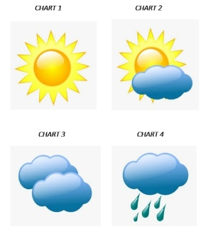  Guide the pupils to describe the following charts.  The four charts show the state of weather at a particular time.  Ask them to state the current state of the atmosphere. | Expected response –  Chart 1 – Sunshine  Chart 2 – Cloudy  Chart 3 – Cloudy Sunshine  Chart 4 – Cloudy Rainfall  Listen to the teacher’s explanation.  The present state of the atmosphere can be one of the four above. | The state of the atmosphere at a particular time – Weather
Step 4  Development  (10 minutes) | Ask the groups to list and draw weather symbols as discussed in step 3. | Groups discussion | Groups work
Step 5  Development  (5 minutes) | Asks each group to present their answers so that you can compare responses with those in other groups. | Presentation | Presentation
Step 6  Conclusion  (5 minutes) | To conclude the lesson, the teacher revises the entire lesson and ask the key questions.  Weather is the state of the atmosphere at a particular time.  The following are the weather symbols - sunny, cloudy, cloudy with sunshine, sunny with rainfall, cloudy with thunder, etc. representing the sun, the rainfall, the cloud, the wind, etc. | The learners listen, ask and answer questions. | Lesson Evaluation and Conclusion

