LESSON DEVELOPMENT TWO

WEATHER RECORDS

STAGE/TIME | TEACHER’S ACTIVITIES | LEARNER'S ACTIVITIES – MIND/HANDS ON | LEARNING POINTS
Step 1  Introduction  (5 minutes) | Ask the pupils to remind you about the different types of weather we have.  Ask them what kind of weather is represented by the symbol. | Expected response –  Rain, wind, sunshine, etc.  Heavy rain, full sun, etc. | Linking the Previous knowledge to the new lesson
Step 2  Development  (5 minutes)  Grouping | 1. Groups the learners into four groups – A, B, C, and D.  2. Guide the learners to choose a leader and secretary for your group.  3. Gives each group learning materials – A ruler and a pen. Weather charts and symbols. | 1. Belong to a group.  2. Choose their leader and secretary.  3. Received learning materials for their group. | Learner’s group, leader and secretary confirmed.
Step 3  Development  (10 minutes) | Lead the pupils outside the classroom to the field or available open space and discuss with them the content of weather chart for record purposes. | 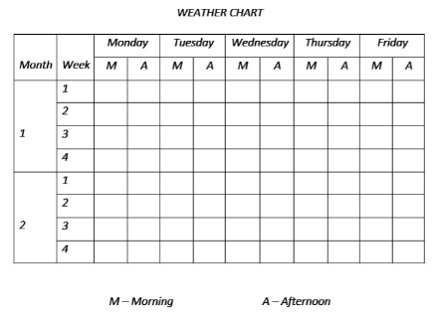 | Weather chart
Step 4  Development  (10 minutes) | For the next two months, guide the groups to use the weather symbols to record the weather in the morning and afternoon.  Add more features to the initial weather symbols to cover the likely weather. | Groups discussion | Groups work
Step 5  Development | The lesson will be concluded after the chart is completed.
Step 6  Conclusion  (10 minutes) | To conclude the lesson, the teacher revises the entire lesson and ask the key questions. | The learners listen, ask and answer questions. | Lesson Evaluation and Conclusion

