LESSON DEVELOPMENT ONE

INTRODUCTION TO ROMAN NUMERALS

STAGE/TIME | TEACHER’S ACTIVITIES | LEARNER'S ACTIVITIES – MIND/HANDS ON | LEARNING POINTS
Step 1  Introduction  (5 minutes) | Ask the pupils to read alphabetical letters from A and Z.  Ask them to write capital letter I, V, X, L, C D and M.  Today, you are going to learn another way of writing numbers called Roman Numerals or Figures. Capital letter I, V, X, L, C D and M are used by Roman Empire to write numbers. It is a secret code.  We are learning the Roman secret numbers. |   Capital letter I, V, X, L, C D and M.  Listen to the teacher’s lesson introduction. | Linking the Previous knowledge to the new lesson
Step 2  Development  (5 minutes)  Grouping | 1. Groups the learners into four groups – A, B, C, and D.  2. Guide the learners to choose a leader and secretary for your group.  3. Gives each group learning materials – Roman Numerals and alphabetical letters Chart | 1. Belong to a group.  2. Choose their leader and secretary.  3. Received learning materials for their group. | Learner’s group, leader and secretary confirmed.
Step 3  Development  (5 minutes) | Tell pupils –  1st letter I = 1  2nd letter V =5  3rd letter X = 10  4th letter L = 50  5th letter C = 100,  6th letter D = 500  7th letter M = 1 000 | 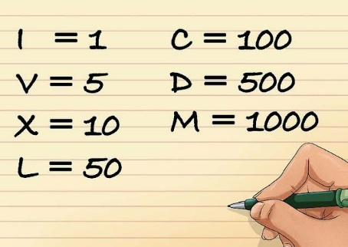 | Roman Numerals – I, V, X, L, C, D and M
Step 4  Development  (10 minutes) | Collect all the charts from each of the group.  Ask them to write the following numbers in Roman Numerals – 1, 5, 10, 50, 100, 500 and 1 000. | Groups work | Evaluation
Step 5  Development  (5 minutes) | Asks each group to present their answers so that you can compare responses with those of other groups. | Presentation | Presentation
Step 6  Conclusion  (10 minutes) | To conclude the lesson, the teacher revises the entire lesson and ask the key questions.  KEY QUESTIONS – WORK TO DO. AT WORK WITH FAMILY AND FRIENDS  Write 1 to 10 in Roman Numerals. | The learners listen, ask and answer questions. | Lesson Evaluation and Conclusion

