LESSON DEVELOPMENT ONE

INTRODUCTION OF PLACE OF NUMBERS UP TO 200

STAGE/TIME | TEACHER’S ACTIVITIES | LEARNER'S ACTIVITIES – MIND/HANDS ON | LEARNING POINTS
Step 1  Introduction  (5 minutes) | Introduction the 10 basic number to the pupils – 0, 1, 2, 3, 4, 5, 6, 7, 8 and 9 on flashcards.  Ask two pupils to pick a card each and identify their number.  Let them stand beside each in the front of the class and the class to say the two digits together.  Ask pupils to change their position and ask the class to say the number. | 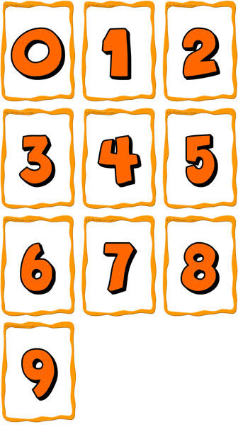  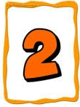  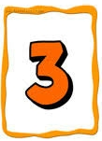  Thirty two  Twenty three | Linking the Previous knowledge to the new lesson
Step 2  Development  (5 minutes)  Grouping | 1. Groups the learners into four groups – A, B, C, and D.  2. Guide the learners to choose a leader and secretary for your group.  3. Gives each group learning materials – Flash cards, counting objects (matches stick or bottle cover know as counter) and number chart | 1. Belong to a group.  2. Choose their leader and secretary.  3. Received learning materials for their group. | Learner’s group, leader and secretary confirmed.
Step 3  Development  (10 minutes) | Tell each group to pick 10 counters and ask their representative to come out.  Ask the class how many 10s is in this group and write the result on the chart.  Ask another representative to join the first group in the front of the class and how many 10s altogether?  Ask the representative in third group to 4 counter and join the other groups.  Ask the class, what is the total counters?  How many 10s and 1s? |   1 Ten = Ten counters    2 Tens = Twenty counters  24  2 Tens and 4 ones = 20 and 4 | Counting in 10s and 1s
Step 4  Development  (5 minutes) | Ask each group to pick counter up to 100.  Repeat the activities in step 3 in 100s. |  | Counting in 100s
Step 5  Development  (10 minutes) | Guide pupils to expand numbers in 100s, 10s and 1s.  Ask 3 groups to come out with their 100 counters, 2 groups with 10 counters and a group with 5 counters.  Let them know that the 1st groups are with 100 counters each, 2nd groups with 10 counters each while 3rd group is with 5 counters.  Ask them, how many 100s, 10s and 1s? And their response on the chart.  Guide the groups to represent 3 Hundreds, 2 Tens and 5 Ones in numbers by counting altogether.  Tell them that 3 = 300, 2 =20 and 5 = 5 | Do as the teacher instructed.  Listen to the teacher’s explanation.  3 Hundreds, 2 Tens and 5 Ones.    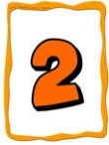  3 Hundreds = 300, 2 Tens = 20 and 5 Ones = 5
Step 7  Conclusion  (10 minutes) | To conclude the lesson, the teacher revises the entire lesson and ask the key questions.  KEY QUESTIONS – How many 100s, 10s and 1s in the following numbers?  1. 132  2. 542 | The learners listen, ask and answer questions. | Lesson Evaluation and Conclusion

