LESSON DEVELOPMENT THREE

PLACE VALUE OF NUMBERS UP TO 200

STAGE/TIME | TEACHER’S ACTIVITIES | LEARNER'S ACTIVITIES – MIND/HANDS ON | LEARNING POINTS
Step 1  Introduction  (5 minutes) | Ask pupils, how many 100s, 10s and 1s are in the following numbers?  1. 132  2. 142  Hundreds, Tens and Ones (Unit) are the place value of each digit in 132 and 142. | Expected response  1 Hundred, 3 Tens and 2 Ones  1 Hundred 4 Ten Ones | Linking the Previous knowledge to the new lesson
Step 2  Development  (5 minutes)  Grouping | 1. Groups the learners into four groups – A, B, C, and D.  2. Guide the learners to choose a leader and secretary for your group.  3. Gives each group learning materials – Flash cards of Hundreds, Tens and Units and of squares box. | 1. Belong to a group.  2. Choose their leader and secretary.  3. Received learning materials for their group. | Learner’s group, leader and secretary confirmed.
Step 3  Development  (10 minutes) | Ask each group to count the number of squares and write the total on the cardboard.  Make sure all the groups arrive at the same number.  Ask them, which of digits represents 100 squares, 40 squares and 3 squares box.  Therefore, the place value of 1 is Hundred, 4 is Tens and 3 Units. | 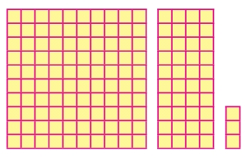  143  1 = 1 Hundred squares box  4 = 4 Tens squares box  3 = 3 Units squares box  Listen to the teacher’s explanation. | Place value of up to 200.
Step 4  Development  (5 minutes) | This table shows the place value of the circled digit and study it carefully. | 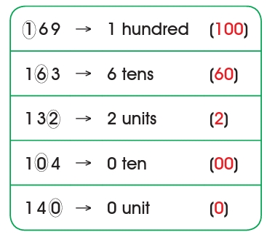 | Place value chart
Step 5  Development  (10 minutes) | Copy and write the place value of the underlined digit.  1. 1 4 5  2. 1 6 7  3. 1 0 0  4. 1 0 4 | Work To Do. | Evaluation
Step 7  Conclusion  (5 minutes) | To conclude the lesson, the teacher revises the entire lesson and ask the key questions. | The learners listen, ask and answer questions. | Conclusion

