LESSON DEVELOPMENT THREE

OBJECTS BASED ON SIZES

STAGE/TIME | TEACHER’S ACTIVITIES | LEARNER'S ACTIVITIES – MIND/HANDS ON | LEARNING POINTS
Step 1  Introduction  (5 minutes) | Ask pupils to identify the following shapes with color on the chart. | 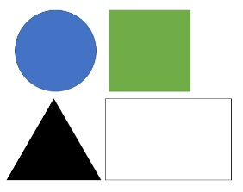  Circle (blue), square (green), triangle (black) and rectangle (white). | Linking the Previous knowledge to the new lesson
Step 2  Development  (5 minutes)  Grouping | 1. Groups the learners into four groups – A, B, C, and D.  2. Guide the learners to choose a leader and secretary for your group.  3. Gives each group learning materials – shapes of circle, triangle, square, rectangle, cuboid, etc. | 1. Belong to a group.  2. Choose their leader and secretary.  3. Received learning materials for their group. | Learner’s group, leader and secretary confirmed.
Step 3  Development  (5 minutes) | Ask pupils to arrange the following shapes according to their sizes. | 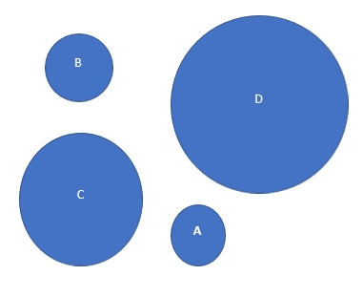 | Arranging shapes according to their sizes.
Step 4  Development  (10 minutes) | Ask pupils you they know bicycle and okada. If their response is yes, which of them is bigger? | Okada is bigger than bicycle. | MIND ON
Step 5  Conclusion  (10 minutes) | To conclude the lesson, the teacher revises the entire lesson and ask the key questions.  KEY QUESTIONS – Identify and arrange the following shapes according to their sizes. | The learners listen, ask and answer questions.  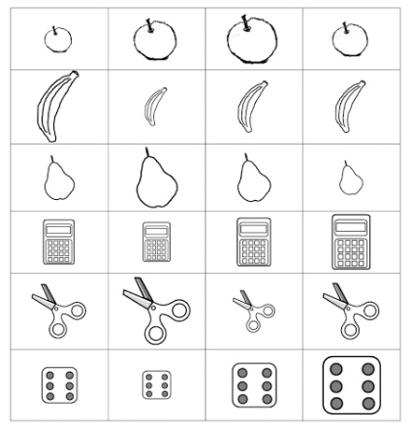 | Lesson Evaluation and Conclusion

