LESSON DEVELOPMENT ONE

COLOUR OF OBJECTS

STAGE/TIME | TEACHER’S ACTIVITIES | LEARNER'S ACTIVITIES – MIND/HANDS ON | LEARNING POINTS
Step 1  Introduction  (5 minutes) | Guide the pupils to identify different colors on the chart. | 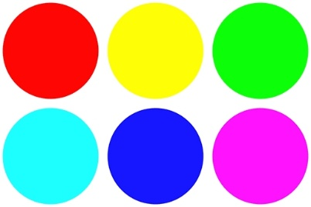  Red, yellow, green, blue, pink, etc. | Linking the Previous knowledge to the new lesson
Step 2  Development  (5 minutes)  Grouping | 1. Groups the learners into four groups – A, B, C, and D.  2. Guide the learners to choose a leader and secretary for your group.  3. Gives each group learning materials – chart and objects of different colors. | 1. Belong to a group.  2. Choose their leader and secretary.  3. Received learning materials for their group. | Learner’s group, leader and secretary confirmed.
Step 3  Development  (10 minutes) | Guide pupils to identify and name number of red, blue, black and yellow colors.  Lead them to count each number of colors identified. | 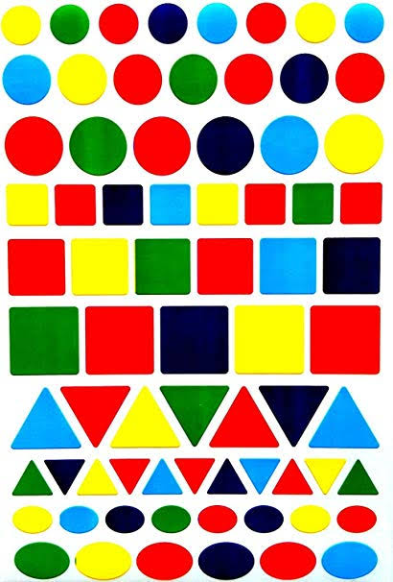 | Identification of colors of Objects.
Step 4  Development  (10 minutes) | Ask pupils to identify objects with red, blue, yellow, black, white, etc. colors in the classroom. | Identifying different of objects in the classroom. | Identification of colors in the classroom
Step 5  Conclusion  (10 minutes) | To conclude the lesson, the teacher revises the entire lesson and ask the key questions.  KEY QUESTIONS  Ask pupils to count and write the number of letters with red, green and yellow colors. | The learners listen, ask and answer questions.  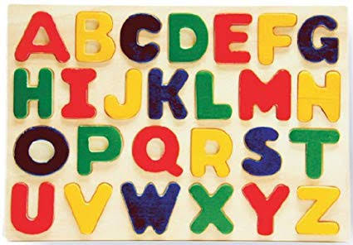 | Lesson Evaluation and Conclusion

