LESSON DEVELOPMENT THREE

ROMAN NUMERALS 1 TO 100

STAGE/TIME | TEACHER’S ACTIVITIES | LEARNER'S ACTIVITIES – MIND/HANDS ON | LEARNING POINTS
Step 1  Introduction  (5 minutes) | Ask pupils to write the following Roman Numerals in Arabic numbers – I, V, X, L, C, D and M. | Expected response –  I = 1, V = 5, X =10, L = 50, C = 100, D = 500 and M = 1 000. | Linking the Previous knowledge to the new lesson
Step 2  Development  (5 minutes)  Grouping | 1. Groups the learners into four groups – A, B, C, and D.  2. Guide the learners to choose a leader and secretary for your group.  3. Gives each group learning materials – Roman Numerals Chart | 1. Belong to a group.  2. Choose their leader and secretary.  3. Received learning materials for their group. | Learner’s group, leader and secretary confirmed.
Step 3  Development  (5 minutes) | Ask the groups to remind you of the two basic rules in writing Roman Numerals.  What is 4, 9, 14, 19, 24, 29, 34, 19, 40, 44 and 49 in Roman Numerals. | BASIC RULES - Number 1 – When a symbol appears after a larger (or equal) symbol it is added. Number 2 – When a symbol appears after a larger (or equal) symbol it is added.  4 = IV, 9 = IX, 14 = XIV, 19 = XIX, 24 = XXIV, 34 = XXXIV, 39 = XXXIX, 40 = XL, 44 = XLIV and XLIX. | Previous Lesson
Step 3B  Development  (5 minutes) | Guide the groups to say the following Roman Numerals in Arabic numbers – I, V, X, XV, XX, XXX, XL, L, LX, LXX, L XX, XC and C. | 1, 5, 10, 15, 20, 30, 40, 50, 60, 70, 80, 90 and 100. | Counting in Roman Numerals in Arabic numbers
Step 4  Development  (10 minutes) | Depending on the number of groups, ask them to write the following in Roman Numerals.  Group A – 1,11, 21, 31, 41, 51, 61, 71, 81, 91 and 100.  Group B – 2, 12, 22, 32, 42, 52, 62, 72, 82, 92 and 100.  Group C – 3, 13, 23, up to 100. | Groups work | Evaluation
Step 5  Development  (5 minutes) | Asks each group to present their answers so that you can compare responses with those of other groups. | Presentation | Presentation
Step 6  Conclusion  (10 minutes) | To conclude the lesson, the teacher revises the entire lesson and ask the key questions.  KEY QUESTIONS – WORK TO DO WITH FRIENDS AND FAMILY  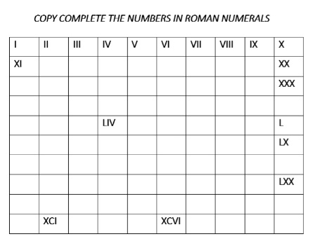 | The learners listen, ask and answer questions. | Lesson Evaluation and Conclusion

