LESSON DEVELOPMENT TWO

WEATHER INSTRUMENTS

STAGE/TIME | TEACHER’S ACTIVITIES | LEARNER'S ACTIVITIES – MIND/HANDS ON | LEARNING POINTS
Step 1  Development –  Introduction  (5 minutes) | Ask the pupils to describe the types of weather we have.  Ask them what the weather is like today? | Expected response – Sunshine, rainfall, temperature, clouds, winds, etc.  Hot, windy, warm, cold, cool, etc. | Linking the Previous knowledge to the new lesson
Step 2  Development – Grouping  (5 minutes) | 1. Groups the learners into four groups – A, B, C, and D.  2. Guide the learners to choose a leader and secretary for your group.  3. Gives each group learning materials – sample or chart showing different weather instruments. | 1. Belong to a group.  2. Choose their leader and secretary.  3. Received learning materials for their group. | Learner’s group, leader and secretary confirmed.
Step 3  Development – Class Discussion  (5 minutes) | Ask the class mention 5 factors affecting weather.  Teacher’s remark – Sometimes the sunshine is hot or warm, rainfall is heavy or light, wind is strong or light, etc. The amount rainfall, the speed and direction, the temperature, etc. can be measured using weather instruments. | Expected response – sunshine, rainfall, clouds, sunshine, temperature, humidity and pressure.  Listen to the teacher’s remark. | Introduction to weather instruments
Step 4  Development – Group Work  (10 minutes) | Discuss the uses of weather instruments with the groups and ask each to draw any one of the following weather instruments on the chart. | Groups discussion  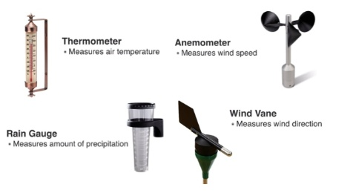 | Groups work
Step 5  Development – Presentation  (5 minutes) | Asks each group to present their answers so that you can compare responses with those in other groups. | Presentation | Presentation
Step 6  Development – Conclusion  (5 minutes) | To conclude the lesson, the teacher revises the entire lesson and ask the key questions.  Weather instruments include – Thermometers (measuring temperature), barometers (measuring pressure), anemometers (measuring wind speed), wind vanes (measuring wind direction), and rain gauges (measuring rainfall). | The learners listen, ask and answer questions. | Lesson Evaluation and Conclusion

