LESSON DEVELOPMENT ONE

MEANING AND TYPES OF EROSION

STAGE/TIME | TEACHER’S ACTIVITIES | LEARNER'S ACTIVITIES – MIND/HANDS ON | LEARNING POINTS
Step 1  Introduction  (10 minutes) | Take the pupils outside to an untarred piece of ground in your school compound. Mark out a certain spot on the piece of soft ground.  Ask a volunteer to pour the bucket of water on the spot from a height of about 5m so that the force of the water can create a hole on the ground.  Ask pupils to observe and describe what happens to the soil. | Follow the teacher’s lead.  Do as the teacher instructed.  The water makes a hole in the ground. | Linking the Previous knowledge to the new lesson
Step 2  Development  (5 minutes)  Grouping | 1. Groups the learners into four groups – A, B, C, and D.  2. Guide the learners to choose a leader and secretary for your group.  3. Gives each group learning materials – 2 buckets of water, hand fans. Soil and trays (per groups), pictures or charts showing erosion. | 1. Belong to a group.  2. Choose their leader and secretary.  3. Received learning materials for their group. | Learner’s group, leader and secretary confirmed.
Step 3  Development  (5 minutes) | Show the class a tray of soil which is at an angle. Ask pupils what will happen if the water is poured onto the tray at the top.  After several pupils have answered, show them what happens.  Teacher’s remark – What you said and see now is called Erosion. What is erosion? | The soil will move from the top of tray down to the button.  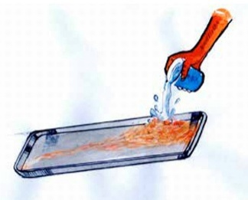  Erosion is the removal of top soil by water. | Types of Erosion – Water Erosion
Step 4  Development  (10 minutes) | Ask each group to invent a way of making a little wind that blows over their soil.  Tell them if they can control the amount of wind then this will be excellent.  Ask the groups to describe what happened to the soil when it is blow by the wind? | Groups discussion | Groups work
Step 5  Development  (5 minutes) | Asks each group to present their answers so that you can compare responses with those in other groups. | Presentation | Presentation
Step 6  Conclusion  (5 minutes) | To conclude the lesson, the teacher revises the entire lesson and ask the key questions.  Erosion is the removal of top soil by water or wind and other human activities such removal of top soil for building houses, construction of roads and bridges or filling deep areas or water.  The more soil that is washed or blown away from the surface, the deeper the erosion that is caused. | The learners listen, ask and answer questions. | Lesson Evaluation and Conclusion

