LESSON DEVELOPMENT THREE

GRAVITY AND WEIGHTLESSNESS

STAGE/TIME | TEACHER’S ACTIVITIES | LEARNER'S ACTIVITIES – MIND/HANDS ON | LEARNING POINTS
Step 1  Introduction  (5 minutes) | Look at the picture and describe the man in the picture.  Teacher’s remark – Listen to them and make a remark based on their description. | 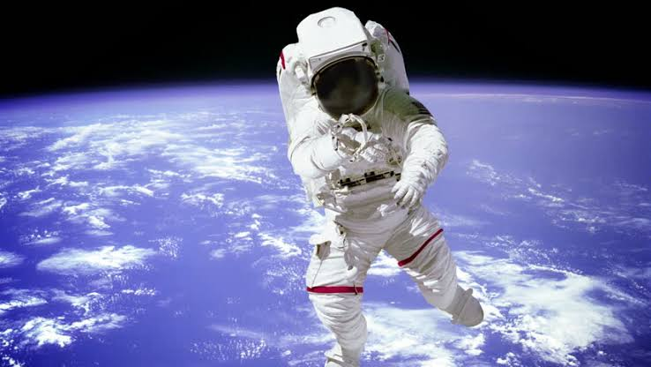 | Linking the Previous knowledge to the new lesson
Step 2  Development  (5 minutes)  Grouping | 1. Groups the learners into four groups – A, B, C, and D.  2. Guide the learners to choose a leader and secretary for your group.  3. Gives each group learning materials – chart and video of people in the space. | 1. Belong to a group.  2. Choose their leader and secretary.  3. Received learning materials for their group. | Learner’s group, leader and secretary confirmed.
Step 3  Development  (10 minutes) | Follow this link – Gravity and Weightlessness. Find a mean to download the video of the above link and let the pupils the video group by group.  Did you know that without gravity, we would fall right off of Earth’s surface and float away?  Gravity is the reason a ball comes back down when you throw it into the air, instead of just traveling higher and higher?  Ask them to describe and compare what happened in the space and on earth. | Pay attention and follow the teacher’s instructions as they watch the video group by group.  Listen to the teacher’s explanation. | Gravity and Weightlessness
Step 4  Development  (10 minutes) | Ask the pupils to wrap up their work within their group. | Groups discussion | Groups work
Step 5  Development  (5 minutes) | Asks each group to present their answers so that you can compare responses with those in other groups. | Presentation | Presentation
Step 6  Conclusion  (5 minutes) | To conclude the lesson, the teacher revises the entire lesson and ask the key questions.  Gravity is a force of attraction that pulls together all matter (anything you can physically touch).  Gravity is also the force that keeps the Earth in orbit around the Sun, as well as helping other planets remain in orbit. | The learners listen, ask and answer questions. | Lesson Evaluation and Conclusion

