LESSON DEVELOPMENT ONE

THE NATURAL BODIES IN OUR SOLAR SYSTEM

STAGE/TIME | TEACHER’S ACTIVITIES | LEARNER'S ACTIVITIES – MIND/HANDS ON | LEARNING POINTS
Step 1  Introduction  (10 minutes) | 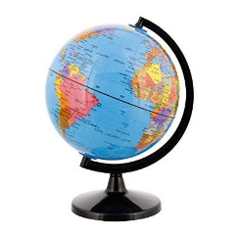  Present the desk globe to the pupils for identification.  Ask them to mention all the things that are on earth. The ones they can see or feel.  Teacher’s remark – The Earth (where we are now!) is one of the natural bodies called Solar System. | Some of pupils have an idea of what the globe is – the Earth we are living.  The land, the mountains, the rivers and the seas are all parts of the earth. Plants and animals are also parts of the earth. Our earth includes the lower parts of the atmosphere, together with all the living and non-living things in it.  Listen to the teacher’s remark and lesson introduction. | Linking the Previous knowledge to the new lesson
Step 2  Development  (5 minutes)  Grouping | 1. Groups the learners into four groups – A, B, C, and D.  2. Guide the learners to choose a leader and secretary for your group.  3. Gives each group learning materials – chart showing the Sun, Earth and all of the planets. | 1. Belong to a group.  2. Choose their leader and secretary.  3. Received learning materials for their group. | Learner’s group, leader and secretary confirmed.
Step 3  Development  (5 minutes) | This is the sun, earth and all of the planets.  Guide and ask class to identify as they the charts carefully. | 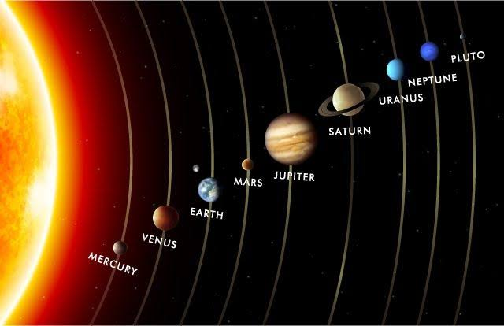 | The sun, earth and all of the planets
Step 4  Development  (10 minutes) | Ask the pupils to wrap up their work within their group. | Groups discussion | Groups work
Step 5  Development  (5 minutes) | Asks each group to present their answers so that you can compare responses with those in other groups. | Presentation | Presentation
Step 6  Conclusion  (5 minutes) | To conclude the lesson, the teacher revises the entire lesson and ask the key questions.  The Solar System includes the Sun, the Earth (where you are now!) and all of the other planets that go around and around it.  There are nine planets in the Solar System. The planets are Mercury, Venus, Earth, Mars, Jupiter, Saturn, Uranus, Neptune and Pluto. | The learners listen, ask and answer questions. | Lesson Evaluation and Conclusion

