LESSON DEVELOPMENT ONE

INTRODUCTION TO EQUIVALENT FRACTIONS

STAGE/TIME | TEACHER’S ACTIVITIES | LEARNER'S ACTIVITIES – MIND/HANDS ON | LEARNING POINTS
Step 1  Introduction  (5 minutes) | Get a cardboard or two. Divide one of it into two equal part and guide the pupils to identify each part as 1/2 not just as half.  Take one part and further divide it into two equal part, guide them to identify each part as 1/4.  Continue this process until the pupils were able to identify each of a whole. | Participate fully as the teacher guide and ask questions.  Each part of the following fractions are –  1/2  2/4  3/6  4/8, etc. | Linking the Previous knowledge to the new lesson
Step 2  Development  (5 minutes)  Grouping | 1. Groups the learners into four groups – A, B, C, and D.  2. Guide the learners to choose a leader and secretary for your group.  3. Gives each group learning materials – Cardboard or divisible objects. | 1. Belong to a group.  2. Choose their leader and secretary.  3. Received learning materials for their group. | Learner’s group, leader and secretary confirmed.
Step 3  Development  (15 minutes) | Guide and ask the pupils to carefully study the chart and identify their similarities. | 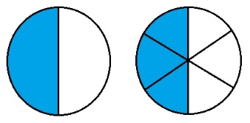 | Equivalent Fractions.
 | Guide the groups –  1. To divide the cardboard into 12, 6 and 3 equal parts.  2. Mark A, B and C on respective cardboards.  Teacher’s remark – To get an equivalent fraction, divide the numerator and the denominator of a fraction by a common factor.  Ask them to compare the fraction parts of 4 As, 2 Be and one C. | 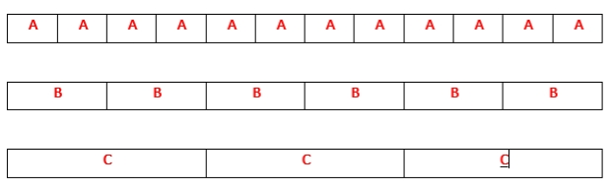  4 As = 4/12  = (2 x 2)/(2 x 6)  = (4 x 1)/(4 x 3)  2 Bs = 2/6  = (1 x 2)/(3 x 2)  1 C = 1/3 | Dividing to find Equivalent Fractions
Step 4  Development  (5 minutes) | Find the missing numbers.  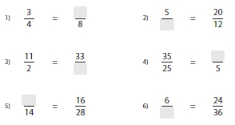 | Groups work. | Groups Evaluation
Step 5  Development  (5 minutes) | Asks each group to present their answers so that you can compare responses with those of other groups.  Call on two or representatives for presentation. | Presentation | Presentation
Step 6  Conclusion  (10 minutes) | To conclude the lesson, the teacher revises the entire lesson and ask the key questions. | The learners listen, ask and answer questions. | Lesson Evaluation and Conclusion

