LESSON DEVELOPMENT ONE

FRACTIONS OF A GROUP

STAGE/TIME | TEACHER’S ACTIVITIES | LEARNER'S ACTIVITIES – MIND/HANDS ON | LEARNING POINTS
Step 1  Introduction  (5 minutes) | Guide the pupils to remember and identify the following shapes. | A circle, square, rectangle and triangle. | Linking the Previous knowledge to the new lesson
Step 2  Development  (5 minutes)  Grouping | 1. Groups the learners into four groups – A, B, C, and D.  2. Guide the learners to choose a leader and secretary for your group.  3. Gives each group learning materials – Two – dimensional shapes. | 1. Belong to a group.  2. Choose their leader and secretary.  3. Received learning materials for their group. | Learner’s group, leader and secretary confirmed.
Step 3  Development  (10 minutes) | Ask pupils, how many triangles are on the chart?  How many triangles are colored?  Teacher’s remark – 1/2 of the group of triangles is coloured. 1/2of 4 triangles = 2 triangles.  Guide the pupils to identify the colored shapes. | There are two triangles.  There are two colored.  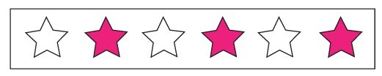  Listen to the teacher’s remark.  1/2 of the group of stars is coloured.  1/2 of 6 stars = 3 stars  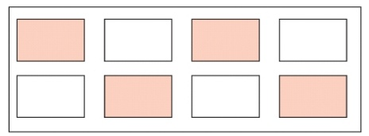  1/2 of the group of rectangles is colored. 1/2 of 8 rectangles = 4 rectangles | Half of a group
Step 4  Development  (5 minutes) | Ask pupils, how many rectangles and balloons are on the chart?  How many rectangles and balloons are colored? | 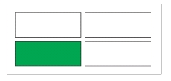  1/4 of the group of rectangles is coloured. 1/4 of 4 rectangles = 1 rectangle.  1/4 of the group of balloons is coloured. 1/4 of 4 balloons = 1 balloon | Quarter of a group
Step 4 B  Development  (5 minutes) | Find the fractions of the colored groups. | 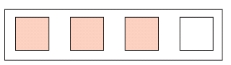  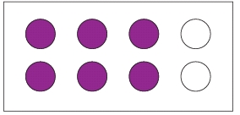 | Group Work
Step 5  Development  (5 minutes) | Asks each group to present their answers so that you can compare responses with those of other groups.  Call one or two groups for presentation. | Presentation | Presentation
Step 6  Conclusion  (5 minutes) | To conclude the lesson, the teacher revises the entire lesson and ask the key questions. | The learners listen, ask and answer questions. | Lesson Evaluation and Conclusion

