QUANTITATIVE REASONING

NAME OF PUPIL ___________________________________________

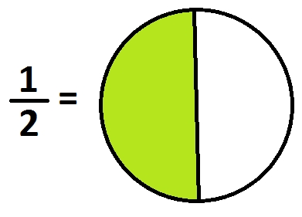
SAMPLE -
