LESSON DEVELOPMENT TWO

INTRODUCTION TO FRACTIONS

STAGE/TIME | TEACHER’S ACTIVITIES | LEARNER'S ACTIVITIES – MIND/HANDS ON | LEARNING POINTS
Step 1  Introduction  (5 minutes) | Present a loaf of bread to the pupils to identify as one whole bread.  Cut the bread into two part to identify as half.  Then introduce today’s lesson as fractions. | 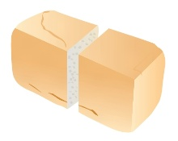  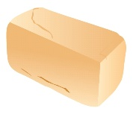  Watch and listen to the teacher’s activities and participate actively. | Linking the Previous knowledge to the new lesson
Step 2  Development  (5 minutes)  Grouping | 1. Groups the learners into four groups – A, B, C, and D.  2. Guide the learners to choose a leader and secretary for your group.  3. Gives each group learning materials – Cardboard or divisible objects. | 1. Belong to a group.  2. Choose their leader and secretary.  3. Received learning materials for their group. | Learner’s group, leader and secretary confirmed.
Step 3  Development  (10 minutes) | Guide groups to divide a whole cardboard into equal part.  Ask them to name each of the part. Let the pupils know that half means 1/2. The 1 at the top is fraction and the 2 below is a whole or the number of parts the cardboard is divided.  Let each group to further divide the parts into two equal part to make 4 parts.  Guide the groups to identify each of the four parts by asking them to pick one part and lead them to name it. Pick 2 and name the two. Pick 3 and name it. Also all the 4 parts and name it.  Demonstrate how 2/4 is the same as 1/2 and 4/4 is 1.  A part you picked is called a fraction and the number of part the cardboard is divided into is called a whole.  What is a fraction? | Pupils follow the teacher’s lead.  Identify each part as half and listen to the teacher’s explanation.  Pupils further divide the cardboard into four equal parts.  1 out of 4 is 1/4 (one over 4) or quarter.  2 out of 4 is 2/4 (2 over 4) or two quarter.  3 out of 4 is 3/4 (3 over 4) or three quarter.  4 out of 4 is 4/4.  Get involved in teacher’s illustrations.  Listen to the teacher’s explanation.  Fraction is a part of a whole. | Meaning of fraction.
Step 4  Development  (5 minutes) | Guide the pupils to identify each part of the fractions – numerator, fraction bar and denominator. | 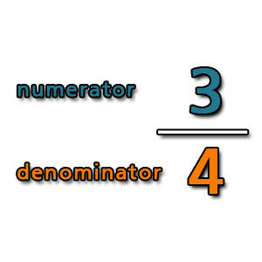
Step 4  Development  (10 minutes) | Answer the following questions –  1. Write the denominator of each fraction – 1/2, 3/4 and 4/7.  2. Write the numerator of each fraction – 2/5, 4/7 and 3/4 | Groups work. | Groups Evaluation
Step 5  Development  (5 minutes) | Asks each group to present their answers so that you can compare responses with those of other groups. | Presentation | Presentation
Step 6  Conclusion  (5 minutes) | To conclude the lesson, the teacher revises the entire lesson and ask the key questions. | The learners listen, ask and answer questions. | Lesson Evaluation and Conclusion

