LESSON DEVELOPMENT THREE

CHANGING FRACTIONS TO DECIMALS AND VICE VERSA

STAGE/TIME | TEACHER’S ACTIVITIES | LEARNER'S ACTIVITIES – MIND/HANDS ON | LEARNING POINTS
Step 1  Introduction  (5 minutes) | Identify the following types of fractions – 5/2, 1/4, 4 1/6, 7/8, 8/7 and 1 7/8. | 1/4 and 7/8 are proper fractions.  5/2 and 8/7 are improper fractions.  4 1/6 and 1 7/8 are mixed fractions. | Linking the Previous knowledge to the new lesson
Step 2  Development  (5 minutes)  Grouping | 1. Groups the learners into four groups – A, B, C, and D.  2. Guide the learners to choose a leader and secretary for your group.  3. Gives each group learning materials – chart showing relationship between fractions and decimals. | 1. Belong to a group.  2. Choose their leader and secretary.  3. Received learning materials for their group. | Learner’s group, leader and secretary confirmed.
Step 3  Development  (10 minutes) | Guide pupils to study the charts.  Ask the questions based on the information on the chart. | 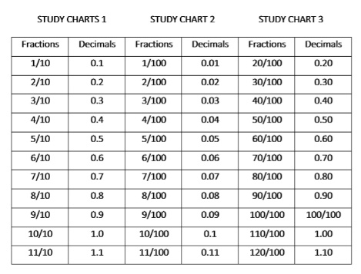 | Relationship between fraction and decimal
Step 4  Development  (5 minutes) | Lead the groups on practical work on how to convert fraction to decimal and vice versa. | Follow the teacher’s lead and instructions. | Changing fraction to decimal and vice versa.
Step 4  Development  (10 minutes) | Based on instructions given, give the groups work to do | Groups work. | Groups Evaluation
Step 5  Development  (5 minutes) | Asks each group to present their answers so that you can compare responses with those of other groups. | Presentation | Presentation
Step 6  Conclusion  (5 minutes) | To conclude the lesson, the teacher revises the entire lesson and ask the key questions.  KEY QUESTIONS – The groups work will be given as work to do to all the pupils. | The learners listen, ask and answer questions. | Lesson Evaluation and Conclusion

STUDY CHARTS 1 STUDY CHART 2 STUDY CHART 3
Fractions | Decimals | Fractions | Decimals | Fractions | Decimals
1/10 | 0.1 | 1/100 | 0.01 | 20/100 | 0.20
2/10 | 0.2 | 2/100 | 0.02 | 30/100 | 0.30
3/10 | 0.3 | 3/100 | 0.03 | 40/100 | 0.40
4/10 | 0.4 | 4/100 | 0.04 | 50/100 | 0.50
5/10 | 0.5 | 5/100 | 0.05 | 60/100 | 0.60
6/10 | 0.6 | 6/100 | 0.06 | 70/100 | 0.70
7/10 | 0.7 | 7/100 | 0.07 | 80/100 | 0.80
8/10 | 0.8 | 8/100 | 0.08 | 90/100 | 0.90
9/10 | 0.9 | 9/100 | 0.09 | 100/100 | 100/100
10/10 | 1.0 | 10/100 | 0.1 | 110/100 | 1.00
11/10 | 1.1 | 11/100 | 0.11 | 120/100 | 1.10

