LESSON DEVELOPMENT TWO

ORDERING OF DECIMALS – ASCENDING AND DESCENDING ORDER

STAGE/TIME | TEACHER’S ACTIVITIES | LEARNER'S ACTIVITIES – MIND/HANDS ON | LEARNING POINTS
Step 1  Introduction  (5 minutes) | Ask the class –  Ascending order means __________. Descending order means __________.  Teacher’s remark – Just like whole numbers and fractions, decimals can be ordered in ascending and descending orders. | Ascending order means smallest first while descending order means largest means.  Listen to the teacher’s remark as he/she introduced the lesson. | Linking the Previous knowledge to the new lesson
Step 2  Development  (5 minutes)  Grouping | 1. Groups the learners into four groups – A, B, C, and D.  2. Guide the learners to choose a leader and secretary for your group.  3. Gives each group learning materials – chart showing relationship between fractions and decimals. | 1. Belong to a group.  2. Choose their leader and secretary.  3. Received learning materials for their group. | Learner’s group, leader and secretary confirmed.
Step 3  Development  (10 minutes) | Leads and guide the pupils to arrange in ascending or descending order – 0.06, 0.2, 0.51 and 0.053.  Guided Instructions  Step 1 – Set up a table with the decimal point in the same place for each number.  Step 2 – Make all digits the same length by filling in extra zero.  Step 3 – Ignore the decimal points and treat the decimals as whole numbers.  Step 4 – Arrange in ascending or descending orders.  Step 5 – Put the decimal points in the correct position.  Note – see that all the pupils are full engaged by following the above instructions. | Follow the teacher’s lead as he/she guides.  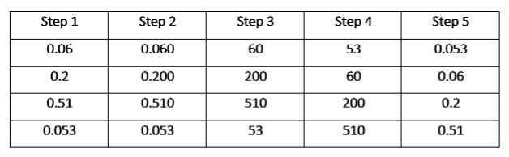  See the full chart below the lesson.  Ascending order – 0.053, 0.06, 0.2 and 0.51.
Step 4  Development  (10 minutes) | Arrange in ascending or descending order –  1. 0.096, 0.3, 0.44 and 0.101  2. 1.8, 0.18, 1.08 and 0.018 | Groups work. | Groups Evaluation
Step 5  Development  (5 minutes) | Asks each group to present their answers so that you can compare responses with those of other groups.  Call one or two groups for presentation. | Presentation | Presentation
Step 6  Conclusion  (5 minutes) | To conclude the lesson, the teacher revises the entire lesson and ask the key questions.  KEY QUESTIONS – ASSIGNMENT  The groups work will be given as work to do at home. | The learners listen, ask and answer questions. | Lesson Evaluation and Conclusion

Step 1 | Step 2 | Step 3 | Step 4 | Step 5
0.06 | 0.060 | 60 | 53 | 0.053
0.2 | 0.200 | 200 | 60 | 0.06
0.51 | 0.510 | 510 | 200 | 0.2
0.053 | 0.053 | 53 | 510 | 0.51

