LESSON DEVELOPMENT TWO

CONTROLLING SOIL EROSION

STAGE/TIME | TEACHER’S ACTIVITIES | LEARNER'S ACTIVITIES – MIND/HANDS ON | LEARNING POINTS
Step 1  Introduction  (5 minutes) | Take the pupils out of the class to an open space (well covered with grasses) within the compound.  Ask a volunteer to pour the bucket of water on the spot from a height of about 5m to see if the force of the water can create a hole on the ground.  Ask the pupils to invent a way of making a little wind that blows over grassland.  Ask them why it is impossible.  Teacher’s remark – It is impossible for the water or wind to easy wash away the top soil when the soil is covered with plants.  This is one of the ways to control soil erosion. | Follow the teacher’s lead and do as instructed.  The water cannot create a hole on the ground.  The wind cannot blow the top soil.  Because the soil is covered with grasses.  Listen to the teacher’s remark as he introduced the lesson. | Linking the Previous knowledge to the new lesson
Step 2  Development  (5 minutes)  Grouping | 1. Groups the learners into four groups – A, B, C, and D.  2. Guide the learners to choose a leader and secretary for your group.  3. Gives each group learning materials – pictures or charts showing erosion. | 1. Belong to a group.  2. Choose their leader and secretary.  3. Received learning materials for their group. | Learner’s group, leader and secretary confirmed.
Step 3  Development  (10 minutes)  Step 4  Development  (5 minutes) | The chart shows different effects of soil erosion. The causes of soil erosion are Clearing/removing the grasses, burning the grass when it is dry allowing animals to graze the grassland, persistent walking on the grassland and tillage.  How can we control or prevent soil erosion from destroying soil, plants, lives and properties? | 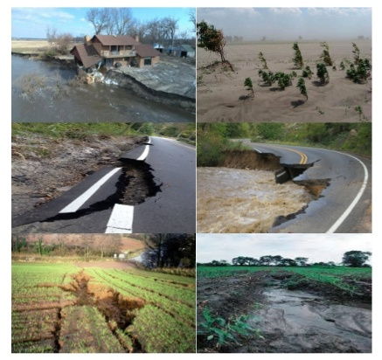  Listen to the teacher’s explanation. | Controlling Soil Erosion
 | Wrap up | Groups discussion | Groups work
Step 5  Development  (5 minutes) | Asks each group to present their answers so that you can compare responses with those in other groups. | Presentation | Presentation
Step 6  Conclusion  (5 minutes) | To conclude the lesson, the teacher revises the entire lesson and ask the key questions. | The learners listen, ask and answer questions. | Lesson Evaluation and Conclusion

